Mapping Target Schemas to Source Schemas
Using WordNet Hierarchies and
Structure Context
by
David Jackman
A thesis submitted to the faculty of
Brigham Young University
in partial fulfillment of the requirements for the degree of
Master of Science
Department of Computer Science
Brigham Young University
November 2026

Brigham Young University
Graduate Committee Approval

of a thesis submitted by
David Jackman

This thesis has been read by each member of the following graduate committee and by majority vote has been found to be satisfactory.

Date David W. Embley, Chair
Date Deryle Lonsdale
Date Bryan S. Morse

Brigham Young University

As chair of the candidate’s graduate committee, I have read the thesis of David Jackman in its final form and have found that (1) its format, citations, and bibliographical style are consistent and acceptable and fulfill university and department style requirements; (2) its illustrative materials including figures, tables, and charts are in place; and (3) the final manuscript is satisfactory to the graduate committee and is ready for submission to the university library.

Date David W. Embley
Chair, Graduate Committee

Accepted for the Department
David W. Embley
Graduate Coordinator

Accepted for the College
G. Rex Bryce
Associate Dean, College of Physical and
Mathematical Sciences

Abstract
Mapping Target Schemas to Source Schemas Using
WordNet Hierarchies and Structure Context

David Jackman
Department of Computer Science
Master of Science

The advent of the World Wide Web has made an immense volume of information on a wide range of subjects available to a large and enquiring public. Much of the time, as information and knowledge is sought on the Web, the answers do not lie in a single source or repository of data. Instead, knowledge and understanding is to be gained by combining the information learned from a variety of sources and integrating it together to form a complete picture. In this thesis, we present two methods for automatically generating mappings from object sets in target schemas to object sets in source schemas for the purpose of data integration. In addition, we present an extensible tool that initially contains these two methods.
The first method for automatic mapping generation involves using the WordNet lexical database of the English language to find object sets that represent similar concepts based on the language used in their descriptions. The second method involves using the context of each object set based on the structure of the target and source schemas to decide which of the mappings generated by the first method is most likely to be correct.
To validate these methods, we run experiments on target and source schemas in four domains: music CDs, real estate, genealogy, and car advertisements. We discuss the accuracy of these generation methods in each of these domains, as well as some of the unique problems that each domain presented.
Acknowledgements

I would like to acknowledge the help and support of many people in this project, including family, friends, and advisors. First and foremost, I would like to thank my wife, TaraLee, and our two daughters for their continued love and support during this project and my entire endeavor to become more educated. I would also like to thank my parents for helping me learn how to work hard and especially how to finish hard things.
I am very grateful to all the professors at BYU I have been privileged to work with during this program, especially to those who have worked closely with me on this thesis. I would like to thank Dr. Deryle Lonsdale for his unique insight and especially for teaching by far the most interesting course I ever took in computer science. I would like to thank Dr. David Embley for his continued support and assistance both as my primary advisor and my graduate coordinator.
This material is partially based upon work supported by the National Science Foundation under Grant No. 0083127. Any opinions, findings, and conclusions or recommendations expressed in this material are those of the author and do not necessarily reflect the views of the National Science Foundation.
Contents
Contents vii
List of Figures ix
List of Tables xi
Chapter 1 Introduction 1
Chapter 2 Related Work 5
Chapter 3 Integration Tool Framework 7
3.1 Overview and Program Flow 7
3.2 Input Documents 10
3.3 Output Documents 12
Chapter 4 Integration Mapping Generation 14
4.1 WordNet Method 14
4.2 Contextual Method 25
Chapter 5 Experimental Analysis and Results 33
Chapter 6 Conclusions, Limitations, and Future Work 39
Bibliography 42
Appendix A Target and Source Schemas 46
Appendix B Integration Tool Input and Output Documents 52

List of Figures
Figure 1: Program flow for Java tool for database schema integration 8
Figure 2: Hypernym hierarchy for sense #1 of the term "bug" 15
Figure 3: Convergence of hypernym hierarchies for the terms “publication” and “article” 16
Figure 4: Sample target and source database schemas which contain duplicate object set descriptions 26
Figure 5: Target schema for Music CDs domain (based on CD Universe
web site) 47
Figure 6: Source schema for Music CDs domain (based on Amazon.com
web site) 48
Figure 7: Source schema for Music CDs domain (All-Music Guide web site) 49
Figure 8: Source schema for Music CDs domain (based on Movie Music
web site) 50
Figure 9: Source schema for Music CDs domain (based on CD Now web site) 51
Figure 10: Sample input parameters document for integration tool 53
Figure 11: Target schema input document for integration tool (based on target schema for Music CDs domain) 56
Figure 12: Output document from integration tool (based on mapping from target schema for Music CDs domain to the source schema from Amazon.com) 65
Figure 13: DTD for mapping documents generated by the integration tool 67

List of Tables
Table 1: Results of experiments for database schema matching on four domains using the WordNet and contextual mapping generation methods 34

Introduction
The advent of the World Wide Web has made an immense volume of information on a wide range of subjects available to a large and enquiring public. Much of the time, as information and knowledge is sought on the Web, the answers do not lie in a single source or repository of data. Instead, knowledge and understanding is to be gained by combining the information learned from a variety of sources and integrating it together to form a complete picture. Obviously, we would like the integration of this information to be as complete and automatic as possible. However, in reality this is an extremely difficult problem, involving many different areas of research and development.
In some instances, information on a topic can be very unorganized and free flowing, such as repositories of poetry or research notes and discussion. In most other cases, information is highly organized, providing different pieces of information on elements in a domain of interest, such as information on music recordings, bibliographic data, and parts inventories. These pieces of information may come directly from relational databases or be extracted from web pages using one of the various data extraction tools being developed.
The goal of data integration is to combine the information provided from multiple sources into a single, virtual repository of information in a specific domain of interest. This may mean combining pieces of information about individual elements of the domain (e.g. fields about specific music CDs) with other pieces of information about the same elements from different sources, or combining the information about some elements with information about other elements from different sources, or both.
In [BE02], Biskup and Embley present a model for integrating several source database schemas with a single target schema (example source and target schemas can be found in Appendix A). In this model, an injective mapping is created from each object set and relationship set in the target schema to the corresponding object sets and relationship sets in each source schema, indicating how requests for data from the target schema are routed to the actual data sources. In some cases, object sets or relationship sets in the target schema may not map directly onto object sets or relationship sets in a source schema. Instead, an object set or relationship set may map onto a query, join, or other operation that is performed on the source data. The Biskup-Embley model also provides rules for dealing with conflicts and discrepancies that may arise when creating mappings in some complex cases.
Our research follows the Biskup-Embley model of data integration, in that it maps object sets from a target schema onto object sets in source schemas, but does not attempt to construct queries, joins, or other operations on source schemas.
In this thesis, we present a method for automatic creation of mappings from target schemas to source schemas as part of the Biskup-Embley model of data integration. In addition, we present an extensible tool we have developed to facilitate data integration. The method uses the language in the schema definitions in conjunction with WordNet to correlate object sets in the different schemas. WordNet is a lexical database of the English language that has done much to further research in natural language processing. The database provides a list of all the noun, verb, and adjective word senses for each word, along with that word sense’s placement in a hierarchy of words within that domain. (For example, apple is a kind of fruit, which is a kind of food.) WordNet is described in detail in [Mil95] and is available for download and review from the WordNet web site ([WN]).
This method then generates mappings for data integration based on the object set correlations produced from the description language, along with contextual information about each object set in relation to other object sets in the schemas.
We present our method and describe our implementation as follows. Chapter 2 provides information on related research in data integration. Chapter 3 describes the extensible data integration tool we developed for this project. Chapter 4 describes the procedures we use to perform automatic matching of schemas. Chapter 5 discusses the results of these methods on experimental data. Finally, Chapter 6 concludes the thesis, indicating the limitations of our approach and providing insight into areas of future research that could improve the results even further.

Related Work
Much research has been devoted to solving the problem of information integration. In the mid-1980’s, research focused on integrating schemas when designing large databases ([BLN86]). In the early 1990’s, this research evolved to integrating whole databases ([SL90], [TTCB+90]). Today, research initiatives are aimed at integrating information from various structured and semi-structured sources. Some attempts (e.g. [CGHP+94], [KLSS95], [Ull97], [Coh98]) integrate the data sources as queries are posed, while others (e.g. [BCV99], [BE99], [FPNB99]) integrate the data sources beforehand, offering a general schema that is queried. Regardless of when the integration takes place, the same problems arise. Arguably the greatest of these challenges is resolving semantic conflicts between two sources. The core of this problem is determining whether object or relationship sets in different sources are related and if so, then whether this relationship is equality, generalization, specialization, or some type of intersection.
Much of the difficulty in automatically resolving semantic conflicts between heterogeneous data sources arises from terminology differences in the different schemas. [BE99] uses keywords and sample values to aid in matching object sets. [Coh98] uses techniques from information retrieval research to approximate a mapping between query terms and schema terms. But most approaches require humans to do much of the work to provide a mapping between heterogeneous schemas.
This research proposes to use the WordNet lexical database to aid in automatically resolving semantic conflicts by providing possible relationships between object and relationship sets of different data sources based on the terminology of those sources and their position in the WordNet word-sense hierarchy. The integration approach in [BCV99] briefly mentions WordNet as a tool that could be used to propose possible relationships between objects sets based on field names, but does not give any details about how this would be done or its effectiveness on real data. [CA99] uses WordNet in conjunction with other thesauri to identify terminological relationships, but no details are given about its effectiveness or limitations.

Integration Tool Framework

Overview and Program Flow
In the course of this project, we developed a flexible tool in Java for facilitating data integration. This program allows the user to create a mapping from a target schema to a source schema using any number of methodologies in any order. Each methodology for mapping generation is implemented by creating a Java class that implements a particular interface, which is understood by the data integration tool.
Figure 1 gives an overview of the program flow for the data integration tool. The user provides input parameters (on the command line and/or through an input document), target schema, and source schema. The integration tool then calls the various mapping generation method implementations (as specified by the input parameters) to generate a mapping from the target schema to the source schema. The output of the integration tool is a document that contains the mapping information.
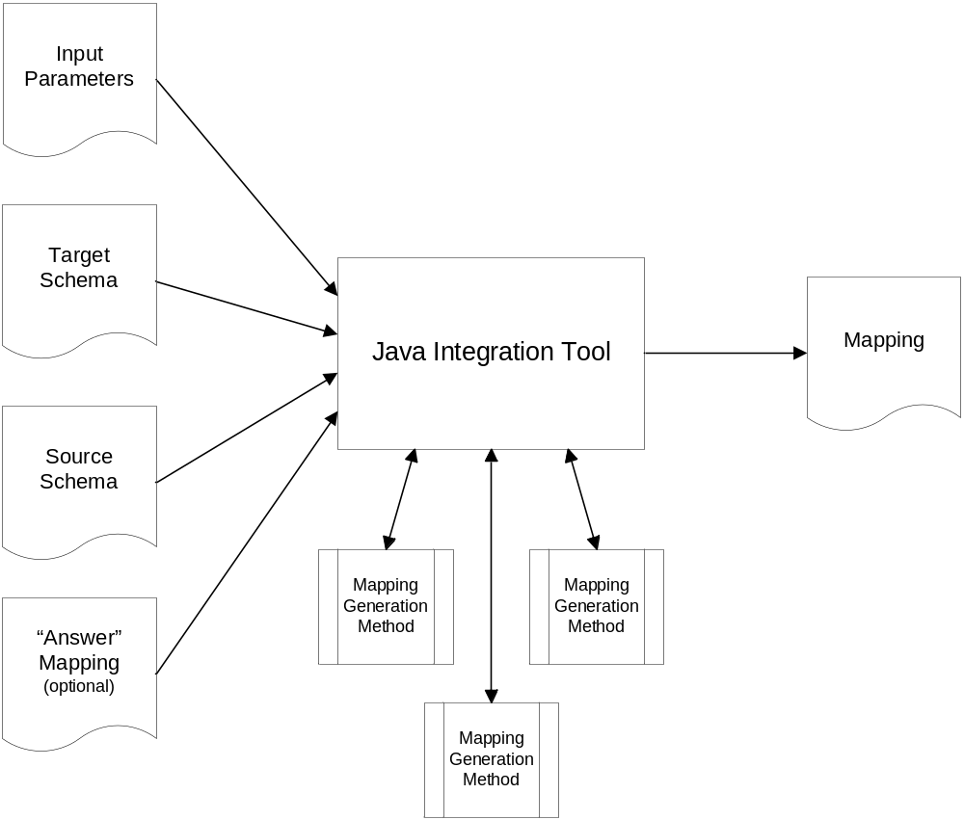
Figure 1: Program flow for Java tool for database schema integration
Each mapping generation method is implemented in a Java class which implements a public interface so it can be called by the integration tool. The methods are invoked by the integration tool in the order specified by the input parameters. The input parameters can also specify options and parameters specific to the mapping generation methods, which can customize their behavior.
When a mapping generation method is invoked, it has access to all the data from the target and source schemas, and also has access to all the mapping data that has been generated to that point. Each element of the mapping includes a target schema object set or relationship set, a source schema object set or relationship set, and one or more scores for that mapping element, which are assigned by the various mapping generation methods. Future projects may enhance the tool to allow for more complex mappings to operations on the source schema, such as joins, queries, etc. A mapping generation method has the ability to create new mapping elements, to add scores to existing mapping elements, and to select mapping elements that should be considered part of the final mapping from the target schema to the source schema. As a mapping generation method performs these tasks, it can function entirely automatically, using external data if necessary, or it can interact with an end user.
The integration tool also has the ability to compare the mapping results generated by the mapping generation methods with an “answer” mapping supplied by the user. When an “answer” mapping is present, the integration tool will also indicate in the output mapping which mapping elements generated by the mapping generation methods are “correct” and which are “incorrect” (false positives). In addition, the integration tool also indicates the false negatives by marking those mapping elements that were generated and scored by the mapping generation methods but not selected, and listing the mapping elements present in the “answer” mapping but not generated by any of the mapping generation methods.
The integration tool also provides overall metrics for the mapping, with the total number of “correct” mapping elements, false positives, false negatives, and the number of mapping elements that were generated but not selected (which is a subset of the false negatives). These metrics can then be used to compare the results of different mapping generation methods, different orderings of mapping generation methods, or different option and parameter values for the mapping generation methods.

Input Documents
There are four input documents for the Java data integration tool, one of which is optional. All input (and output) documents for the tool are XML documents. The input documents include the target and source schemas, the input parameter document, and an optional “answer” mapping file. Sample input documents from our experimentation are shown in Appendix B.
The target and source schema documents use the OSM document type definition which was created for the Ontology Editor described in [Hew00]. However, the integration tool does not use all the information provided by the OSM DTD. Currently, the tool only reads information about the object sets and relationship sets in the schema, and only uses the lexical, read-only, high level, and primary attributes for object sets. For relationship sets, the tool uses the information about which object sets are connected by the relationship and any participation constraints on those connections.
The input parameters document specifies all the information the integration tool needs to generate a mapping, including the location of the other input documents, the name of the output document, and information about what mapping generation methods should be used. Each mapping generation method is specified by the name of the Java class which implements it. In addition, each mapping generation method may also have a set of named parameters which are also specified in the input parameters document, and are given to the mapping generation method object before it is invoked. The input parameters document uses a custom DTD designed specifically for the integration tool.
The optional “answer” mapping document uses the mapping DTD, which is described in detail in the next section.

Output Documents
The output document from the data integration tool is also an XML document, which uses a document type definition that was designed for this project, but can be a general DTD for target-to-source mappings based on the Biskup-Embley model for data integration. However, some additional features have been added to the DTD which are specific for this integration tool. A sample output document and the mapping DTD are shown in Appendix B.
The mapping DTD specifies the location of the target and source schema documents to which the mapping pertains. Optional elements follow, which contain result information based on the comparison of the generated mapping with the “answer” mapping supplied by the user, including metrics on correct and incorrect matches and a list of the matches that exist in the “answer” mapping but are not in the mapping generated by the integration tool. The remainder of the mapping document contains zero or more match elements, each of which corresponds to a single mapping component, specifying an object or relationship set in the target schema and the corresponding object or relationship set in the source schema. (For this project, no additional complexity in mapping components was necessary, so no ability to map onto operations over the source schemas was built into the mapping DTD.)
Each match element contains scoring elements to indicate how the various mapping generation methods considered the match. There are two types of scoring elements. The first type is based on the measures and constraints outlined in the Biskup-Embley model for data integration. Each match element has one or none of these scores. The second type is a much simpler score given to the match by the individual mapping generation methods. Each match element contains one of these scoring elements for each of the mapping generation methods that considered the match, and it specifies which mapping generation method provided the score and the score it received (a value between 0 and 1). We discuss each of the mapping generation methods we used in the next chapter.
Each match element also has an “selected” attribute, which is true if the mapping generation methods decide that the match should be included as part of the final mapping from target to source. The final mapping is then the set of all selected matches in the mapping document. The mapping document also contains the “unselected” matches for the purpose of analyzing the results of the various mapping generation methods. If an “answer” mapping is provided by the user, then a “correct” attribute is also present for each match, indicating whether the value of the “selected” attribute is correct based on the “answer” mapping.

Integration Mapping Generation
For this research, we created two mapping generation methods for the data integration tool. The first mapping method (the WordNet method) is based on our research to automatically generate matches for object sets based on the language used in the object set labels. The second mapping method (the contextual method) takes the results of the first method and selects matches based on the structural context of the object sets with other matched object sets.

WordNet Method
The WordNet method automatically creates matches based on the hypernym hierarchy for terms used in target and source schema definitions. The hypernym hierarchy contains terms that define the more general classes of entities defined by the original term. For example, the diagram in Figure 2 on the following page shows the hypernym hierarchy for the word “bug.”
Naturally, a single word in the English language will have more than one meaning or word sense. The term “bug” in WordNet has five distinct word senses: a general term for an insect, a fault or defect in a system or machine, a small hidden microphone, insects with sucking mouthparts and forewings thickened and leathery at the base, and a germ or disease-causing bacterium. (Figure 2 shows the hypernym hierarchy for the first of these word senses of the term “bug.”) Each of these word senses has its own hypernym hierarchy. WordNet assigns each word sense to a “synset”, (short for “synonym set”) which represents the distinct meaning of that word sense, and may have senses of other synonymous words assigned to it as well (for example, sense #2 of “message”, sense #2 of “content”, sense #1 of “subject matter”, and sense #6 of “substance” all belong to the same WordNet synset, meaning “what a communication that is about something is about”).
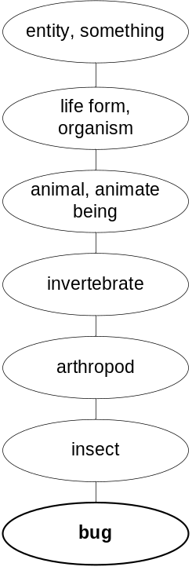
Figure 2: Hypernym hierarchy for sense #1 of the term "bug"
To create potential matches from object sets in the target schema to objects sets in the source schema, we consider every pair of target and source object sets. For each pair, we take the hypernym hierarchies for all the word senses for the description term, looking for a root term, where the hypernym hierarchy for a word sense of the term from the target object set converges with the hierarchy for a word sense of the term from the source object set. For example, Figure 3 shows how the hypernym hierarchies for the term “publication” and the term “article” converge to the common root term “creation”. (In the diagram, the number following a term indicates the word sense number for the term in the WordNet lexicon.)
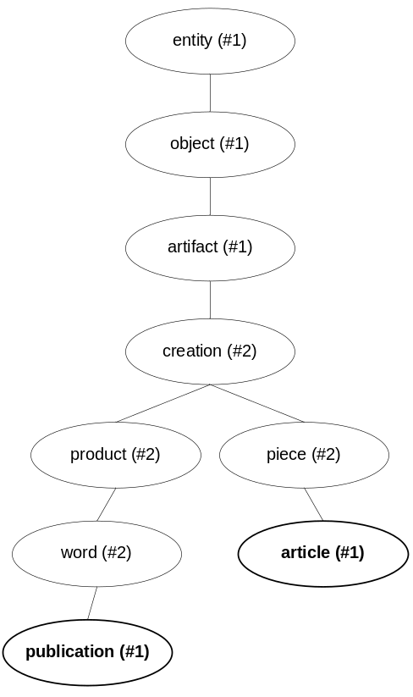
Figure 3: Convergence of hypernym hierarchies for the terms “publication” and “article”
WordNet divides all noun terms into 26 categories, based on the concept they express. One of these categories, called “Noun.Tops,” contains nouns that are very general in concept and are found at the top one to three levels of almost every hypernym hierarchy (in the hierarchies shown in Figure 3, the terms “entity,” “object,” and “artifact” are all in the Noun.Tops category). Because terms in this category are so general, we do not use common root terms which are in the Noun.Tops category. If the only common root term for a pair of terms X and Y is in this category, we say that X and Y do not represent similar concepts.
Only one term can be used from the object set description for the WordNet method. To get this term, we parse the object set description to find the last term that is a noun, stopping when we have reached the end of the description or a preposition. For example, the description “publication date” and “date of publication” both yield the term “date” as the term used for the WordNet method for this description. We use WordNet to determine the part of speech of each term, and a static list of words to determine prepositions.
Some terms in the WordNet lexicon actually consist of two consecutive English words (e.g., “air conditioning,” “floor plan,” and “square foot”). Because of this, our procedure for isolating the last noun term from the description attempts to look up the two-word combination of the last noun and the word preceding it in the description. If that combination of words exists as a term in the WordNet lexicon, that term is used for that object set in the WordNet method.
To implement the WordNet method, we used version 1.0 of the JWordNet library, which is a Java-based interface to the WordNet lexicon originally developed by Oliver Steele at Brandeis University [OS]. Although Steele has abandoned the project, it is usable enough for this research except for a few minor bugs which we fixed, and the addition of some (very limited) morphological processing code translated from the standard C-based WordNet library, which we use to convert terms we find in the description text to their base forms (which usually just means removing plurality). Recently, the JWordNet code was picked up by Kurt Hayes and moved to the SourceForge repository, and can now be found at [JWN].
Once we have found two terms (call them X and Y) whose hypernym hierarchies converge to one or more common root terms, we can measure several metrics about this relationship. Each of these terms has been given an identifying name for easy reference.
- NumberOfRootTerms: The number of common root terms for X and Y.
- XYSenseCount: The number of senses of X plus the number of senses of Y.
- MinSenseCount: The number of senses of X or the number of senses of Y, whichever is smaller.
- MaxSenseCount: The number of senses of X or the number of senses of Y, whichever is larger.
- XYPolysemyCount: The polysemy count of X plus the polysemy count of Y. (Polysemy is a standard WordNet value for a term indicating how “common” the word’s usage is.)
- MinPolysemyCount: The polysemy count of X or the polysemy count of Y, whichever is smaller.
- MaxPolysemyCount: The polysemy count of X or the polysemy count of Y, whichever is larger.
- MinCategories: The number of categories of X or the number of categories of Y, whichever is smaller. (The number of categories for a term is the number of unique categories among all the senses of the word.)
- MaxCategories: The number of categories of X or the number of categories of Y, whichever is larger.
- MinSpecRootSynsets: The smallest number of specialized root synsets over all the common roots of X and Y. (A “specialized root synset” is the topmost parent of a root term that is not in the Noun.Tops category. MinSpecRootSynsets is not a defined metric in WordNet, but one we invented for this implementation.)
- MaxSpecRootSynsets: The largest number of specialized root synsets over all the common roots of X and Y.
For the next four metrics, we use the sum of the distance from X to a root and the distance from Y to that root over all the common roots. We call this value XYDistance.
- SmallestXYDistance: The smallest value of XYDistance over all the common roots.
- Small_XYDifference: The difference between the distance from X to the root and the distance from Y to the root, for the common root that gave us the value for SmallestXYDistance.
- LargestXYDistance: This is the largest value of XYDistance over all the common roots. (If there is only one common root for X and Y, this value will be the same as SmallestXYDistance.)
- Large_XYDifference: The difference between the distance from X to the root and the distance from Y to the root, for the common root that gave the value for LargestXYDistance.
We use these metrics to provide a score (between zero and one) for the X-Y match, wanting the pair to score high for correct matches (where the object set X in the target schema represents the same objects or class of objects as the object set Y in the source schema). To come up with a formula for this score based on the above metrics, we used the Weka machine learning tool ([CH99]), with the J4.8 PART algorithm, which builds decision rules based on the C4.5 decision tree learner [Quin93].
To create training data, we calculated the metrics for sample term pairs from correct and incorrect matches between source schemas from two different domains. We used all of the correct matches and 20% of the incorrect matches so there would be approximately an even mix for the learner (this represented metrics for approximately 550 term pairs, of which about 135 were correct matches). We also added a cost factor that made false negatives 10 times worse than false positives, because the main purpose of this method is to come up with potential matches—not necessarily correct matches. (The contextual method, discussed next, will determine which of the potential matches is correct.)
The decision algorithm derived by J4.8PART for our training data is as follows. The algorithm is executed from top down and stops whenever a decision is reached. The numbers following each “yes” decision indicate the number of times that particular decision was reached during training, followed by the number of times the decision was reached incorrectly. For “no” decisions, the number indicates the number of times that particular decision was reached during training. (Because the cost factor penalizes false negatives, there were no incorrect “no” decisions for the training data.) The values were given after the cost factor was applied, which explains the fractional values.
- SmallestXYDistance = 0: yes (293.62/3.86)
- SmallestXYDistance <= 2 AND MaxCategories <= 4 AND XYSenseCount <= 13: yes (50.22/1.93)
- MinSenseCount <= 6 AND Small_XYDifference <= 2 AND SmallestXYDistance > 4 AND LargestXYDistance <= 6: no (29.62)
- Small_XYDifference <= 2 AND XYSenseCount <= 6 AND MinSenseCount <= 1: yes (28.98/3.22)
- SmallestXYDistance > 2 AND MaxSenseCount > 7 AND LargestXYDistance <= 8: no (53.44)
- MaxCategories > 3 AND Small_XYDifference <= 2 AND MinSpecRootSynsets <= 5 AND MinCategories > 2 AND XYSenseCount > 12: yes (41.85/6.44)
- XYSenseCount > 11: no (9.66)
- NumberOfRootTerms > 1: no (9.66)
- Small_XYDifference > 0 AND Small_XYDifference <= 2 AND MaxCategories > 4 AND MinCategories > 2: yes (7.73/1.29)
- MinSenseCount > 2: no (10.3)
- MaxSpecRootSynsets <= 5: yes (7.73/1.29)
- If none of the above rules has generated a decision, then the decision is no (4.19)
Observe that the most important criteria is the SmallestXYDistance metric. This reflects the strong correlation between the hypernym distance to a common root and the similarity of the concept conveyed by the terms, which is the basis for generating mappings in the WordNet method. Four of the first five criteria use this metric, and low values for this metric result in generating a mapping with a high confidence value. The various metrics involving sense counts (including the “categories” metrics) are also important. A high number of senses for either or both of the terms indicates an increasing possibility that the senses of the terms that are related through WordNet may not be senses of those terms as they are used in the schemas.
It is also interesting that none of the metrics involving polysemy (the commonality of the term) were used at all in the formula. While we thought a more common term might indicate a greater likelihood that the terms should match, this indication was completely overshadowed by the metrics involving word senses. (Had there been a polysemy value specific to a word sense, this value might have made more of a contribution.)
For each pair of terms that has any common roots, we apply the formula above to generate a score for that match, which represents a confidence level for that match based on the similarity of the terms. If the decision generated by the formula is “no,” the score is 0.0, which means we are confident that the term pair should not match. If the decision generated by the formula is “yes,” the score is calculated as 1 – (I / R), where I is the number of times the rule was reached incorrectly during training and R is the number of times the rule was reached during training. For example, if the first rule above evaluates as true to generate the decision “yes,” the score given to that match from the WordNet method is 1 - (3.86 / 293.62), or 0.987.

Contextual Method
While the WordNet method identifies potential matches of target and source object sets based on description text, the object set names alone are not enough to determine which matches should be selected for the final mapping of target schema to source schema. The following example demonstrates this point. Figure 4 on the following page shows a source schema containing two object sets with the description “Title.” The WordNet method generates high scores for the term pairs (Title, Title) and (Publication Name, Title). However, the WordNet method cannot distinguish between the two titles in the source schema and decide which title should be matched with the target title and which title should be matched with the target publication name.
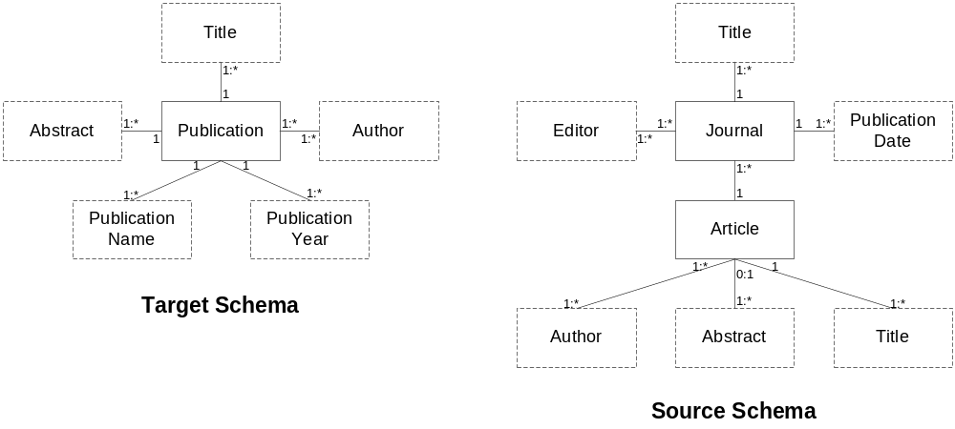
Figure 4: Sample target and source database schemas which contain duplicate object set descriptions
The contextual matching method takes potential matches identified by the WordNet method and provides an additional score for these matches based on the matched object sets to other object sets in the target and source schemas. The matches with the highest context score are then selected as “correct” matches for the final target-to-source mapping.
To perform the context matching method, we first sort the list of object sets from the target schema in order of importance, with the most “important” object set being first in the list. The importance of an object set is a value between zero and one, with a higher number indicating a higher importance. The importance value for a given object set is the number of relationships that object set participates in divided by the maximum number of relationships that any object set participates in for the entire schema. Note that the object set with the most relationship sets in a schema will always have an importance value of 1.0).
We then look at each of the object sets in the target schema in order of importance (established in the above operation) and consider all the non-zero WordNet matches in which each target object set participates. For each of those matches, we use an algorithm (described below) to produce a context score for the match. Whichever match for that target object set has the highest context score is then selected for the final target-to-source mapping. If multiple matches have the same context score, they are all selected.
We use the following algorithm to determine the context score for a single match. This match has a single target object set (TOS) and a single source object set (SOS). The algorithm computes a sub-score for each of the object sets directly related to TOS in the target schema (we call these the adjacent object sets). The context score for the TOS-SOS match is then the average of the sub-scores for all the adjacent objects in the target. Each sub-score for an adjacent object set is computed from several different metrics, and a separate sub-score is computed for each match in which the adjacent target object set participates. The largest sub-score for that adjacent target object set is then used in the average over all the adjacent target object sets to compute the context score for the original match.
We use the following metrics to compute a sub-score. The sub-score is the product of all of these metrics. There are four object sets that are used to calculate these metrics: the target object set (TOS), the source object set (SOS), the object set adjacent to the target object set (ATOS), and the object set in the source schema that matches with ATOS (ASOS). Each of these metrics was invented based on observations of matching and non-matching object sets in various sample schemas. The constant values used in the metrics were selected by intuition and by empirical experimentation, with the larger non-1.0 factors indicating those metrics that are less likely to indicate a match, and the smaller non-1.0 factors indicating those metrics that are more likely to indicate a match.
- distanceFactor: The formula for this metric is 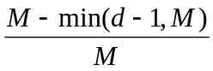, where d is the distance between (number of relationship sets between) SOS and ASOS in the source schema, and M is a maximum distance allowed. We used a value of 5 for M in our experiments. We chose this value based on observation of various source schemas and noticing that 5 was the maximum distance between object sets in a schema that could ever realistically be described with a single relationship in another schema.
- importanceFactor: The absolute value of the difference between the importance value for TOS in the target schema and the importance value for SOS in the source schema, subtracted from 1.0. (This value is higher when TOS and SOS represent a similar importance in their respective schemas.)
- methodScore: The WordNet score for the TOS-SOS match.
- methodScoreAdj: The WordNet score for the ATOS-ASOS match, unless the ATOS-ASOS match has already been selected by the context method. In this case, the value for this metric is 1.0.
- functionalMatch: If the relationship between TOS and ATOS is functional and the relationship between SOS and ASOS is also functional, or if both relationships are not functional, then this value is 1.0. Otherwise, this value is 0.8. We chose this value by observing correct and incorrect matches of object sets among source schemas. While many of the correct matches did have agreement on functionality, there was no real correlation between correct matches and functionality agreement.
- optionalMatch: If the relationship between TOS and ATOS is optional and the relationship between SOS and ASOS is also optional, or if both relationships are not optional, then this value is 1.0. Otherwise, this value is 0.8. We chose this value by observing correct and incorrect matches of object sets among source schemas. While many of the correct matches did have agreement on optionality, there was no real correlation between correct matches and optionality agreement.
- leafNodeMatchAdj: If ATOS is a leaf node in the target schema and ASOS is a leaf node in the source schema, or if both are not leaf nodes, then this value is 1.0. Otherwise, this value is 0.3. We chose this value by observing correct and incorrect matches of object sets among source schemas. In these cases, it was extremely unlikely to have a leaf node matching with a non-leaf node.
- lexicalMatchAdj: If ATOS is lexical and ASOS is lexical, or both are not lexical, then this value is 1.0. Otherwise, this value is 0.2. We chose this value by observing correct and incorrect matches of object sets among source schemas. In these cases, it was extremely unlikely to have a lexical object set matching with a non-lexical object set.
- sourceAlreadyMapped: If SOS already participates in a match previously selected by the context method, then this value is 0.3. Otherwise, this value is 1.0. We chose the 0.3 value by observing matches between source schemas and other source schemas. If a source object set already participates in a previously selected match, then this match was most likely with a target object set which was ranked as having a greater importance. We observed that the matches for the most important target object sets were most often correct.
- sourceAlreadyMappedAdj: If ASOS already participates in a match previously selected by the context method (which isn’t the match to ATOS), then this value is 0.5. Otherwise, this value is 1.0. We chose the 0.5 value by observing matches between source schemas and other source schemas, similar to the sourceAlreadyMapped metric described above. In this case, the adjacent source object sets are not as likely to be correct matches, so we used a higher value.
Each of these factors addresses a different aspect of similarity between object sets in two different schemas. The distanceFactor considers the context of the object set in the schema. The method scores consider the likelihood of a match based on the other methods. The other scores consider some quantifiable aspect of the object sets based on the structure of the schema. If the two object sets are similar in their lexicality, functionality, optionality, etc., there is a greater likelihood that they will match. Some of these features (e.g. lexicality) are much more likely to indicate that the pair should not be matched if the features are not common for both object sets. These factors have very low values when the features are not the same. Others, like optionality, are less effective in predicting a match when not the same and thus have higher values.
As an example, consider the two possible matches for “title” to “title” in Figure 4. To distinguish the two “title” object sets in the source, we will refer to the journal title as “title1” and the article title as “title2”. The only object set in the target adjacent to “title” is “publication”. For this example, we will assume “publication” has already been matched with “article” in the source. Hence, for computing the various metrics for the contextual method, TOS is “title”, SOS is either “title1” or “title2”, ATOS is “publication”, and ASOS is “article”.
The distanceFactor value for “title1” is 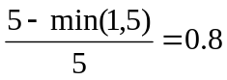. The distanceFactor value for “title2” is 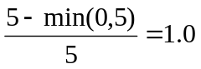. Both “title1” and “title2” have the same number of relationships in which they participate, so they have the same importance value (0.25). TOS has an importance value of 0.2, so the importanceFactor value for “title1” and “title2” is 0.95. The methodScore value is also the same for “title1” and “title2”: 0.987. Since ASOS has already been matched with ASOS, the methodScoreAdj value is 1.0 for both “title1” and “title2”. The relationship from TOS to ATOS has a constraint of 1:*, which is not functional. The relationships from both “title1” and “title2” to ASOS are also 1:*. Therefore, the functionalMatch values for “title1” and “title2” are 1.0, and the optionalMatch values for “title1” and “title2” are also 1.0. Since TOS, “title1”, and “title2” are all leaf nodes, the leafNodeMatchAdj values for “title1” and “title2” are 1.0. Since ATOS is lexical and ASOS is lexical, the lexicalMatchAdj values for “title1” and “title2” are 1.0. Since neither “title1” nor “title2” are in any other selected matches, they both have a sourceAlreadyMapped value of 1.0. Since ASOS doesn’t participate in a selected match to anything other than ATOS, the sourceAlreadyMappedAdj values for both “title1” and “title2” are 1.0.
Given these metrics, the contextual method score for “title1” is
0.8 * 0.95 * 0.987 * 1.0 * 1.0 * 1.0 * 1.0 * 1.0 * 1.0 * 1.0 = 0.75
and the contextual method score for “title2” is
1.0 * 0.95 * 0.987 * 1.0 * 1.0 * 1.0 * 1.0 * 1.0 * 1.0 * 1.0 = 0.938
Therefore, the match of “title” to “title2” would be selected in the final mapping.

Experimental Analysis and Results
To test the effectiveness of the WordNet and contextual data matching methods, we created source schemas using existing web sites as a guide. We used four to seven web sites from four different domains (music CDs, real estate, genealogy, and car ads). With each web site, we extracted object set descriptions using the field name text that appeared on the web pages describing individual data records. We then inferred the relationships between these object sets based on their presentation on the web pages and our own knowledge of the domain. The source schemas we used for the music CDs domain are given in Appendix A as an example.
For target schemas, we used a similarly constructed schema based on an additional web site in the domain [URL1] (for music CDs), a standard DTD for the domain taken from [XML] (real estate), a standard form for the domain taken from [PED](genealogy), and a target schema constructed for another research project [ECJ+99] (car ads). The target schema we used for the music CDs domain is given in Appendix A as an example.
Table 1: Results of experiments for database schema matching on four domains using the WordNet and contextual mapping generation methods
Domain | Correct | False Negatives | False Positives
Music CD’s | 25 (56%) | 20 | 36 (1.5%)
Real Estate | 26 (33%) | 54 | 216 (1.5%)
Genealogy | 14 (47%) | 16 | 24 (6.5%)
Car Ads | 30 (91%) | 3 | 5 (0.2%)
Totals | 95 (51%) | 93 | 281 (1.6%)

Table 1 shows the overall results for the schema matching experiments in the different domains. The percent correct is calculated from the number correct compared to the total matches for the human-generated answer. False negatives are matches that appear in the answer but were not generated by the mapping generation methods. False positives are matches generated by the mapping generation methods but did not appear in the answer, with the percentage showing the fraction of the total possible false positives. Each domain presented its own challenges, each of which demonstrates ways this initial research can be improved.
The car ads domain clearly got the best results from these schema matching methods. However, this domain also gave the simplest matching problems to solve. The WordNet method for schema matching works well when the names of target and source object sets are different, but the semantics are generally the same. The contextual method for schema matching works best when the basic structure of the target and source schemas is similar.
Results from the WordNet method are based on the literal meanings of single-word descriptions. However, in many cases, target and source object sets strayed from one of these overall premises. In some cases, schemas would take semantic license and use description terms where the underlying data did not match the literal meaning of the terms. For example, in the music CDs domain, the term “artist” was sometimes used as a description for data that actually consisted of artist names. When the other schema uses the more literal description of “artist name”, the WordNet method then discards the pairing as a possible match because the term “artist” is not semantically similar to the term “name” based on hypernym hierarchies.
In other cases, the single word used by the WordNet method to find possible matches is not descriptive enough for the object set—too much meaning from the complete description is lost when reducing it to a single word. The effect of this problem was most pronounced in the genealogy domain. In this domain, most of the schemas had the same overall structure and attributes. However, the bulk of the object sets centered around dates and places for various events (e.g. birth date/place, death date/place, marriage date/place, etc.). The term used in the WordNet method for the descriptions of “birth date”, “death date”, and “marriage date” are all simply “date”. When this oversimplification happens, incorrect matches get the same scores as correct matches.
In a few cases, both of these problems were manifest at the same time. The best example of this was in the real estate domain, where object sets containing the number of bedrooms was either described as “number of bedrooms” (a description which is oversimplified to “number” by the WordNet method) or “bedrooms” (a term whose literal meaning does not accurately describe the corresponding data). This problem was then repeated for object sets such as number of bathrooms, number of floors, and garage size.
The contextual method faced problems of its own with the experimental data. The most common problem was when the structure of one schema was significantly more complex than the other schema. In addition, when this problem was present there were often a large number of object sets in the more complex schema that did not apply to anything in the other schema, and should have been left out of the final mapping. Instead, because of the nature of the contextual method, these extra object sets created scores of extra possible matches, clouding the correct matches from being selected. One example of this was in the music CD domain, where the schema for the AllMusic Guide web site contained an entire sub-schema about artists, including names, dates, styles, and reviews, where most of the other schemas were build solely on information about CDs.
Another significant problem hindering the results of the contextual method was actually due to a problem with the results of the WordNet method. The success of the contextual method relies heavily on the success of correctly matching the most important object sets of the target and source schemas. However, when the most important object sets are not matched correctly, all other matches are in jeopardy because the relationship between object sets being considered and the object set matched with the important object set from the target schema is skewed.
This problem was most pronounced in the real estate domain. In this domain, roughly half of the schemas used the term “listing” as the descriptive term for the central object set in the schema. The other half used the term “property”. While these terms are more or less correct descriptions semantically, according to WordNet they are not syntactically similar, and as such receive no WordNet score. This problem, coupled with the fact that the target schema used in the real estate domain (taken from the standard DTD for the real estate industry) was considerably more complex than of all the source schemas (taken from actual real estate web sites), resulted in extremely poor performance.

Conclusions, Limitations, and Future Work
Experiments using the mapping generation methods described in this paper produced results ranging from 91% accuracy in one domain to 33% in another, with an overall accuracy of 51%. Each domain we used for experiments demonstrated interesting traits, which revealed different strengths and weaknesses of our method.
While the results of this research are not as promising as we had originally hoped, they are still far from discouraging. There is much more ground to cover in this research, with many more experiments to run. Many of the problems we saw in this project can be overcome with improvements to the techniques we’ve started here.
Obviously, a WordNet-based matching algorithm is not enough to perform the work of automatic schema matching, especially in more real-world applications, where object sets and relationship sets from target schemas do not map directly onto object sets and relationship sets from source schemas, but rather to operations over source schemas. Analysis of description terms simply is not enough to create these sophisticated mappings. But this WordNet information is a valuable asset when combined with other data, such as expected values.
WordNet-based matching would also benefit by adding the concept of a “primary attribute” to the OSM model. With this concept, the schema for AllMusic Guide would declare that the primary attribute for the “artist” non-lexical object set is “name”, meaning this is the attribute that is commonly used to refer to the non-lexical object. With this information, when the WordNet algorithm sees a lexical object set with the description “artist”, which would score highly with the non-lexical “artist” in the other schema, it can then create the more likely match of “artist” to the lexical “name” attribute of “artist”.
Many of the problems we saw with the WordNet algorithm can be reduced with some analysis of the single words to which each description is reduced. When more than one object set description reduces to the same single term, it becomes impossible to find the correct match for these object sets. For these cases, the WordNet algorithm would benefit by extracting a secondary term from these objects sets as well (e.g. “birth” from “birth date”, and “bedrooms” from “number of bedrooms”). When the WordNet algorithm finds potential matches for the primary terms, it can then look for similarities with secondary terms among those matches to improve the scores of the more likely matches.
There is also a need for a method of discovering shorthand descriptions, for example when the description “floors” is used for an object set that actually contains data about the number of floors for the house. Obviously, this is a much more difficult problem to solve; one that requires more semantic analysis than syntactic analysis. But further research in this area could provide some additional heuristics that may reveal syntactic clues that can identify the problem and ways to overcome it.
WordNet-based syntactical analysis is still a young area of research in the field of schema matching, and there are some interesting problems to overcome. However, it is our belief that these limitations can be overcome and this type of analysis will be a valuable asset to the arsenal of solutions that, when combined, will make automatic mapping generation for data integration a usable reality.
Bibliography
[BCV99] S. Bergamaschi, S. Castano, and M. Vincini. “Semantic Integration of Semistructured and Structured Data Sources”. SIGMOD Record 28 (1), March 1999, pp. 54-59.
[BE02] J. Biskup, and D. Embley. “Extracting Information from Heterogeneous Information Sources Using Ontologically Specified Target Views”. Information Systems, to appear.
[BLN86] C. Batini, M. Lenzerini, and S. B. Navathe. “A Comparative Analysis of Methodologies for Database Schema Integration”. ACM Computing Surveys. 18(4):323-364, December 1986.
[CA99] S. Castano, and V. De Antonellis. “ARTEMIS: Analysis and Reconciliation Tool Environment for Multiple Information Sources”. Proceedings of the Convegno Nazionale Sistemi di Basi di Dati Evolute (SEBD 99): 341-356, Como, Italy, June 1999.
[CGHP+94] S. Chawathe, H. Garcia-Molina, J. Hammer, Y. Papakonstantinou, J. Ullman, and J. Widom. “The Tsimmis Project: Integration of Heterogeneous Information Sources”. In Proceedings of 100th Anniversary Meeting of the Information Processing Society of Japan, pages 7-18, Tokyo, Japan, October 1994.
[CH99] Sally Jo Cunningham, and Geoffrey Holmes. “Developing Innovative Applications of Machine Learning”. Proc Southeast Asia Regional Computer Confederation Conference, Singapore, 1999.
[Coh98] W.W. Cohen. “The WHIRL Approach to Integration: An Overview”. In Proceedings of the AAAI Workshop on AI and Information Integration, Madison, Wisconsin, July 1998.
[ECJ+99] D.W. Embley, D.M. Campbell, Y.S. Jiang, S.W. Liddle, D.W. Lonsdale, Y.-K. Ng, and R.D. Smith. “Conceptual-Model-Based Data Extraction from Multiple-Record Web Pages”. Data & Knowledge Engineering, 31(3): 227-251, November 1999.
[EKW92] D.W. Embley, B.D. Kurtz, and S.N. Woodfield. Object-oriented Systems Analysis: A Model-Driven Approach. Prentice Hall, Englewood Cliffs, New Jersey, 1992.
[Emb98] D.W. Embley, Object Database Development: Concepts and Principles. Addison-Wesley, Reading, Massachusetts, 1998.
[FPNB99] J. Fowler, B. Perry, M. Nodine, and B. Bargmeyer. “Agent-Based Semantic Interoperability in InfoSleuth”. SIGMOD Record, 28(1): 60-67, March 1999.
[GLSR00] Paulo B. Golgher, Alberto H.F. Laender, Altigran S. da Silva, Berthier Ribeiro-Neto. “An Example-Based Environment for Wrapper Generation”. Proceedings of the International Conference on the World Wide Web and Conceptual Modeling, Salt Lake City, Utah, 9-12 October 2000 (to appear).
[Hew00] Kimball A. Hewett, "An Integrated Ontology Development Environment for Data Extraction," Masters Thesis, Brigham Young University, April 2000.
[JWN] JWordNet home page: http://jwn.sourceforge.net
[KLSS95] Thomas Kirk, Alon Y. Levy, Yehoshua Sagiv, and Divesh Srivastava. “The Information Manifold”. In Working Notes of the AAAI Spring Symposium on Information Gathering from Heterogeneous, Distributed Environments, 1995.
[Mil95] G. Miller. “WordNet: a lexical database for English.” In: Communications of the ACM 38 (11), November 1995, pp. 39-41.
[OS] Oliver Steele home page: http://www.cs.brandeis.edu/~steele/
[PED] Example of standard pedigree chart form: http://www.misbach.org/pdfcharts/pedigree_chart.pdf
[Quin93] J.R. Quinlan. C4.5: Programs for machine learning. Morgan Kaufmann, San Mateo, CA, 1993.
[SL90] A. Sheth, and J. Larson. “Federated Database Systems for Managing Distributed, Heterogeneous, and Autonomous Databases”. ACM Computing Surveys. 22(3):183-236, September 1990.
[TTCB+90] G. Thomas, G. R. Thompson, C.-W. Chung, W. Barkmeyer, F. Carter, M. Templeton, S. Fox, and B. Hartman. “Heterogeneous Distributed Database Systems for Production Use”. ACM Computing Surveys. 22(3):237-266, September 1990.
[Ull97] Jeffrey D. Ullman. “Information Integration Using Logical Views”. Proceedings of the 6th International Conference on Database Theory (ICDT'97): 19-40. Delphi, Greece, January 1997.
[URL1] CD Universe Web Site. www.cduniverse.com. Last accessed March 2002.
[URL2] Amazon.com Web Site. www.amazon.com. Last accessed March 2002.
[URL3] All Music Guide Web Site. www.allmusic.com. Last accessed March 2002.
[URL4] MovieMusic.com Web Site. www.moviemusic.com. Last accessed March 2002.
[URL5] CD Now Web Site. www.cdnow.com. Last accessed March 2002.
[WN] WordNet home page: http://www.cogsci.princeton.edu/~wn/w3wn.html
[XML] The XML Catalog, listing organizations producing industry-specific XML DTDs: http://xml.org/xmlorg_registry/index.shtml
Appendix A
Target and Source Schemas
To illustrate the type and complexity of target and source schemas, this appendix contains the target and source schemas for the Music CDs domain that we used in the experiments.
The target schema is based on the CD Universe web site [URL1]. The source schemas are based on Amazon.com [URL2], the All-Music Guide [URL3], Movie Music [URL4], and CD Now [URL5].
[Emb98] contains a full explanation of the syntax of the schemas (OSM graphs) we use in this thesis. Briefly, rectangles denote sets of objects, with dotted borders indicating lexical object sets (like “name” and “list price”) and solid borders indicating nonlexical object sets (like “CD” and “cover art”, whose objects represent real-world entities). Lines connecting object set rectangles denote sets of relationships between the object sets they connect. Relationship sets typically have a verb phrase and an arrow indicating direction of the verb phrase. For these examples, the verb phrase for all relationship sets is “has” and the direction arrow goes toward leaf nodes in the diagram. Participation constraints for objects in relationships are found at the connection point of an object set with a relationship set, denoted by one number or two numbers separated with a colon (:) character. These values indicate the minimum and maximum number of times a single object participates in the relationship (an asterisk (*) indicates any number is allowed).
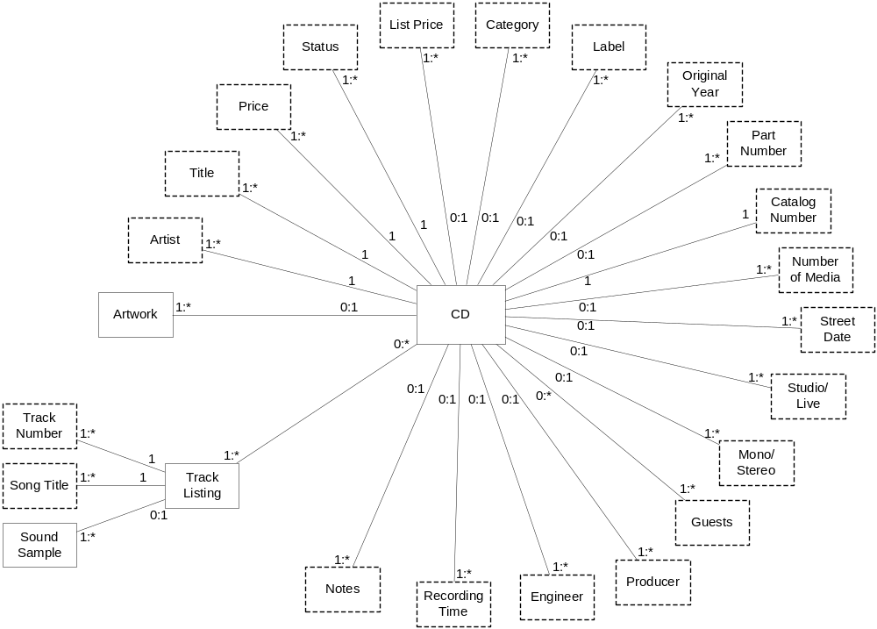
Figure 5: Target schema for Music CDs domain (based on CD Universe web site)
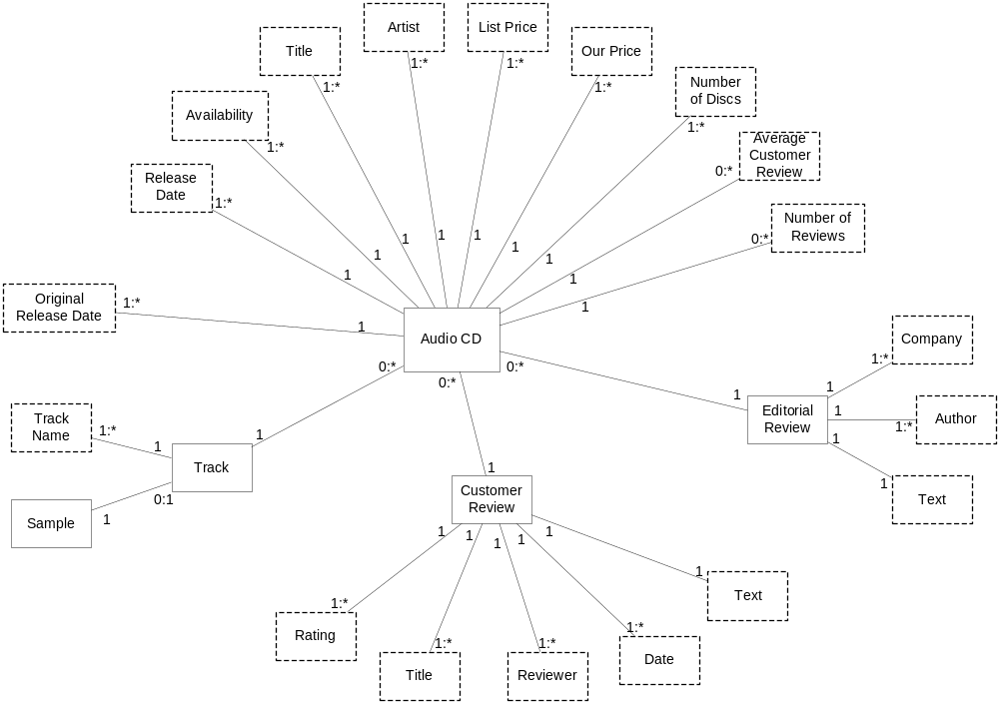
Figure 6: Source schema for Music CDs domain (based on Amazon.com web site)
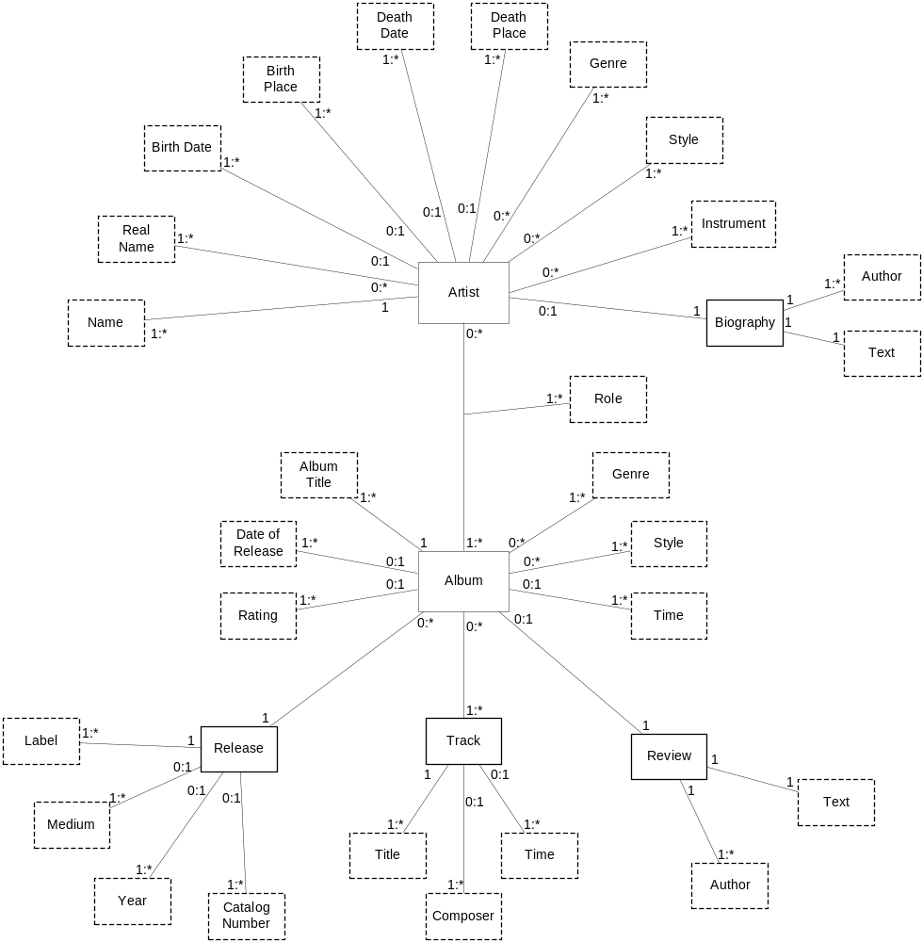
Figure 7: Source schema for Music CDs domain (All-Music Guide web site)
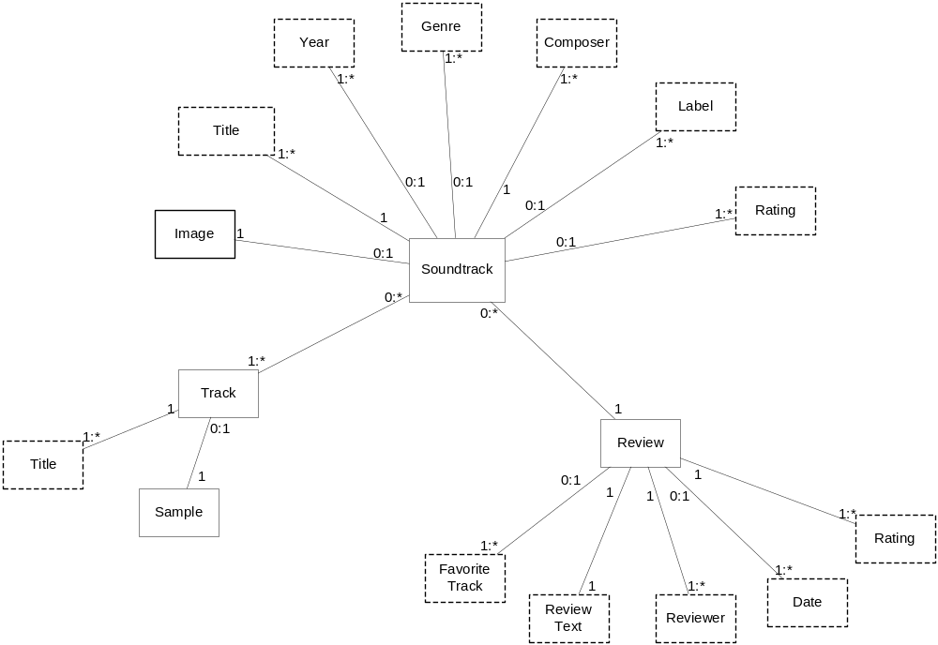
Figure 8: Source schema for Music CDs domain (based on Movie Music web site)
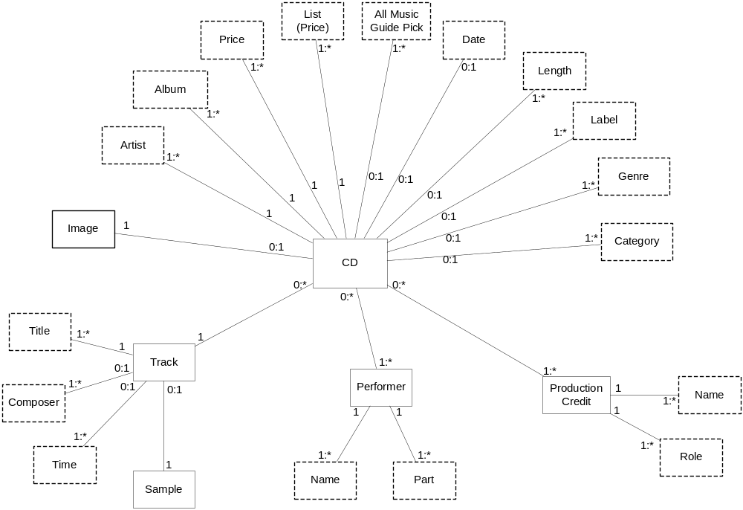
Figure 9: Source schema for Music CDs domain (based on CD Now web site)
Appendix B
Integration Tool Input and Output Documents
To illustrate the input and output data for the integration tool, this appendix contains sample input and output documents for the integration tool for the Music CDs domain we used in the experiments. The DTD for the output (mapping) documents is also given.
The first input document is the input parameters document, which contains the parameters for generating a mapping from the target schema to the Amazon.com source schema for the Music CDs domain. The second input document is based on the target schema for Music CDs (which is based on the CD Universe web site [URL1], and shown in Appendix A). Similar input documents are taken from the source schemas as well. The output document is for a mapping from the target schema to the source schema for the Amazon.com web site [URL2].
<?xml version="1.0" encoding="UTF-8"?>
<!DOCTYPE MapGenInput SYSTEM 'MapGenInput.DTD'>
<MapGenInput>
<Target_OSM src='CD.Source.Target.xml' />
<Source_OSM src='CD.Source.Amazon.xml' />
<Output name='CD.Mapping.Target-Amazon.xml' />
<Answer src='CD.Answer.Target-Amazon.xml' />
<ShowStats value='yes' />
<Method class="WordNetMaker">
<Param name="ScoringMethod" value="j48PART" />
<Param name="ScoreAllPairs" value="no" />
</Method>
<Method class="ContextMaker">
<Param name="AdjTargetMappedMultiplier" value="none" />
</Method>
</MapGenInput>
Figure 10: Sample input parameters document for integration tool

<?xml version="1.0" encoding="UTF-8"?>

<!DOCTYPE OSM SYSTEM 'osm.dtd'>

<OSM x="0" y="0" ID="50" width="1450" height="1067">
<ObjectSet x="460" y="304" HighLevel="N" ID="1" Name="CD" width="90" height="63" order="25" />
<ObjectSet x="211" y="226" HighLevel="N" ID="2" Name="Artist" Lexical="Y" order="26" />
<ObjectSet x="244" y="162" HighLevel="N" ID="3" Name="Title" Lexical="Y" order="27" />
<ObjectSet x="298" y="116" HighLevel="N" ID="4" Name="Price" Lexical="Y" order="28" />
<ObjectSet x="369" y="74" HighLevel="N" ID="5" Name="Status" Lexical="Y" order="29" />
<ObjectSet x="450" y="58" HighLevel="N" ID="6" Name="List Price" Lexical="Y" order="30" />
<ObjectSet x="538" y="61" HighLevel="N" ID="7" Name="Category" Lexical="Y" order="31" />
<ObjectSet x="622" y="82" HighLevel="N" ID="8" Name="Label" Lexical="Y" order="32" />
<ObjectSet x="681" y="121" HighLevel="N" ID="9" Name="Original Year" Lexical="Y" order="33" />
<ObjectSet x="738" y="175" HighLevel="N" ID="10" Name="Part number" Lexical="Y" order="34" />
<ObjectSet x="784" y="236" HighLevel="N" ID="11" Name="Catalog number" Lexical="Y" order="35" />
<ObjectSet x="781" y="301" HighLevel="N" ID="12" Name="Number of Media" Lexical="Y" order="36" />
<ObjectSet x="769" y="371" HighLevel="N" ID="13" Name="Street Date" Lexical="Y" order="37" />
<ObjectSet x="744" y="437" HighLevel="N" ID="14" Name="Studio/Live" Lexical="Y" order="38" />
<ObjectSet x="710" y="497" HighLevel="N" ID="15" Name="Mono/Stereo" Lexical="Y" order="39" />
<ObjectSet x="658" y="571" HighLevel="N" ID="16" Name="Guests" Lexical="Y" order="40" />
<ObjectSet x="568" y="595" HighLevel="N" ID="17" Name="Producer" Lexical="Y" order="41" />
<ObjectSet x="463" y="593" HighLevel="N" ID="18" Name="Engineer" Lexical="Y" order="42" />
<ObjectSet x="324" y="583" HighLevel="N" ID="19" Name="Recording Time" Lexical="Y" order="43" />
<ObjectSet x="201" y="436" HighLevel="N" ID="20" Name="Track Listing" order="44" />
<ObjectSet x="287" y="528" HighLevel="N" ID="21" Name="Notes" Lexical="Y" order="45" />
<ObjectSet x="54" y="365" HighLevel="N" ID="22" Name="Track Number" Lexical="Y" order="46" />
<ObjectSet x="69" y="436" HighLevel="N" ID="23" Name="Song Title" Lexical="Y" order="47" />
<ObjectSet x="51" y="512" HighLevel="N" ID="24" Name="Sound Sample" order="48" />
<ObjectSet x="203" y="301" HighLevel="N" ID="25" Name="Artwork" order="49" />
<RelationshipSet order="50" ID="26" RightArrow="N">
<RelationshipSetName> <Text text=" " x="356" y="255" order="23" /> </RelationshipSetName>
<Connection ObjectSet="1" order="51">
<ParticipationConstraint> <Text text="1" x="419" y="288" order="52" /> </ParticipationConstraint>
</Connection>
<Connection ObjectSet="2" order="53">
<ParticipationConstraint> <Text text="1:*" x="249" y="226" order="54" /> </ParticipationConstraint>
</Connection>
</RelationshipSet>
<RelationshipSet order="55" ID="27" RightArrow="N">
<RelationshipSetName> <Text text=" " x="368" y="219" order="22" /> </RelationshipSetName>
<Connection ObjectSet="1" order="56">
<ParticipationConstraint> <Text text="1" x="422" y="268" order="57" /> </ParticipationConstraint>
</Connection>
<Connection ObjectSet="3" order="58">
<ParticipationConstraint> <Text text="1:*" x="280" y="169" order="59" /> </ParticipationConstraint>
</Connection>
</RelationshipSet>
<RelationshipSet order="60" ID="28" RightArrow="N" x="404" y="225">
<RelationshipSetName> <Text text=" " x="404" y="197" order="21" /> </RelationshipSetName>
<Connection ObjectSet="1" order="61">
<ParticipationConstraint> <Text text="1" x="449" y="260" order="62" /> </ParticipationConstraint>
</Connection>
<Connection ObjectSet="4" order="63">
<ParticipationConstraint> <Text text="1:*" x="339" y="136" order="64" /> </ParticipationConstraint>
</Connection>
</RelationshipSet>
<RelationshipSet order="65" ID="29" RightArrow="N">
<RelationshipSetName> <Text text=" " x="444" y="176" order="20" /> </RelationshipSetName>
<Connection ObjectSet="1" order="66">
<ParticipationConstraint> <Text text="1" x="470" y="253" order="67" /> </ParticipationConstraint>
</Connection>
<Connection ObjectSet="5" order="68">
<ParticipationConstraint> <Text text="1:*" x="401" y="103" order="69" /> </ParticipationConstraint>
</Connection>
</RelationshipSet>
<RelationshipSet order="70" ID="30" RightArrow="N">
<RelationshipSetName> <Text text=" " x="492" y="168" order="19" /> </RelationshipSetName>
<Connection ObjectSet="1" order="71">
<ParticipationConstraint> <Text text="0:1" x="492" y="237" order="72" /> </ParticipationConstraint>
</Connection>
<Connection ObjectSet="6" order="73">
<ParticipationConstraint> <Text text="1:*" x="485" y="84" order="74" /> </ParticipationConstraint>
</Connection>
</RelationshipSet>
<RelationshipSet order="75" ID="31" RightArrow="N">
<RelationshipSetName> <Text text=" " x="538" y="169" order="18" /> </RelationshipSetName>
<Connection ObjectSet="1" order="76">
<ParticipationConstraint> <Text text="0:*" x="519" y="240" order="77" /> </ParticipationConstraint>
</Connection>
<Connection ObjectSet="7" order="78">
<ParticipationConstraint> <Text text="1:*" x="538" y="88" order="79" /> </ParticipationConstraint>
</Connection>
</RelationshipSet>
<RelationshipSet order="80" ID="32" RightArrow="N">
<RelationshipSetName> <Text text=" " x="579" y="180" order="17" /> </RelationshipSetName>
<Connection ObjectSet="1" order="81">
<ParticipationConstraint> <Text text="1" x="542" y="253" order="82" /> </ParticipationConstraint>
</Connection>
<Connection ObjectSet="8" order="83">
<ParticipationConstraint> <Text text="1:*" x="632" y="110" order="84" /> </ParticipationConstraint>
</Connection>
</RelationshipSet>
<RelationshipSet order="85" ID="33" RightArrow="N">
<RelationshipSetName> <Text text=" " x="623" y="198" order="16" /> </RelationshipSetName>
<Connection ObjectSet="1" order="86">
<ParticipationConstraint> <Text text="0:1" x="563" y="266" order="87" /> </ParticipationConstraint>
</Connection>
<Connection ObjectSet="9" order="88">
<ParticipationConstraint> <Text text="1:*" x="698" y="150" order="89" /> </ParticipationConstraint>
</Connection>
</RelationshipSet>
<RelationshipSet order="90" ID="34" RightArrow="N">
<RelationshipSetName> <Text text=" " x="651" y="230" order="15" /> </RelationshipSetName>
<Connection ObjectSet="1" order="91">
<ParticipationConstraint> <Text text="0:1" x="582" y="285" order="92" /> </ParticipationConstraint>
</Connection>
<Connection ObjectSet="10" order="93">
<ParticipationConstraint> <Text text="1:*" x="748" y="201" order="94" /> </ParticipationConstraint>
</Connection>
</RelationshipSet>
<RelationshipSet order="95" ID="35" RightArrow="N">
<RelationshipSetName> <Text text=" " x="667" y="265" order="14" /> </RelationshipSetName>
<Connection ObjectSet="1" order="96">
<ParticipationConstraint> <Text text="1" x="597" y="303" order="97" /> </ParticipationConstraint>
</Connection>
<Connection ObjectSet="11" order="98">
<ParticipationConstraint> <Text text="1" x="767" y="243" order="99" /> </ParticipationConstraint>
</Connection>
</RelationshipSet>
<RelationshipSet order="100" ID="36" RightArrow="N">
<RelationshipSetName> <Text text=" " x="665" y="297" order="13" /> </RelationshipSetName>
<Connection ObjectSet="1" order="101">
<ParticipationConstraint> <Text text="0:1" x="605" y="322" order="102" /> </ParticipationConstraint>
</Connection>
<Connection ObjectSet="12" order="103">
<ParticipationConstraint> <Text text="1:*" x="755" y="297" order="104" /> </ParticipationConstraint>
</Connection>
</RelationshipSet>
<RelationshipSet order="105" ID="37" RightArrow="N">
<RelationshipSetName> <Text text=" " x="659" y="332" order="12" /> </RelationshipSetName>
<Connection ObjectSet="1" order="106">
<ParticipationConstraint> <Text text="0:1" x="607" y="346" order="107" /> </ParticipationConstraint>
</Connection>
<Connection ObjectSet="13" order="108">
<ParticipationConstraint> <Text text="1:*" x="742" y="375" order="109" /> </ParticipationConstraint>
</Connection>
</RelationshipSet>
<RelationshipSet order="110" ID="38" RightArrow="N">
<RelationshipSetName> <Text text=" " x="647" y="367" order="11" /> </RelationshipSetName>
<Connection ObjectSet="1" order="111">
<ParticipationConstraint> <Text text="0:1" x="588" y="369" order="112" /> </ParticipationConstraint>
</Connection>
<Connection ObjectSet="14" order="113">
<ParticipationConstraint> <Text text="1:*" x="721" y="407" order="114" /> </ParticipationConstraint>
</Connection>
</RelationshipSet>
<RelationshipSet order="115" ID="39" RightArrow="N">
<RelationshipSetName> <Text text=" " x="639" y="404" order="10" /> </RelationshipSetName>
<Connection ObjectSet="1" order="116">
<ParticipationConstraint> <Text text="0:1" x="571" y="392" order="117" /> </ParticipationConstraint>
</Connection>
<Connection ObjectSet="15" order="118">
<ParticipationConstraint> <Text text="1:*" x="690" y="485" order="119" /> </ParticipationConstraint>
</Connection>
</RelationshipSet>
<RelationshipSet order="120" ID="40" RightArrow="N">
<RelationshipSetName> <Text text=" " x="600" y="441" order="9" /> </RelationshipSetName>
<Connection ObjectSet="1" order="121">
<ParticipationConstraint> <Text text="0:*" x="546" y="416" order="122" /> </ParticipationConstraint>
</Connection>
<Connection ObjectSet="16" order="123">
<ParticipationConstraint> <Text text="1:*" x="666" y="548" order="124" /> </ParticipationConstraint>
</Connection>
</RelationshipSet>
<RelationshipSet order="125" ID="41" RightArrow="N">
<RelationshipSetName> <Text text=" " x="587" y="487" order="8" /> </RelationshipSetName>
<Connection ObjectSet="1" order="126">
<ParticipationConstraint> <Text text="0:1" x="512" y="417" order="127" /> </ParticipationConstraint>
</Connection>
<Connection ObjectSet="17" order="128">
<ParticipationConstraint> <Text text="1:*" x="588" y="571" order="129" /> </ParticipationConstraint>
</Connection>
</RelationshipSet>
<RelationshipSet order="130" ID="42" RightArrow="N">
<RelationshipSetName> <Text text=" " x="499" y="452" order="7" /> </RelationshipSetName>
<Connection ObjectSet="1" order="131">
<ParticipationConstraint> <Text text="0:1" x="478" y="414" order="132" /> </ParticipationConstraint>
</Connection>
<Connection ObjectSet="18" order="133">
<ParticipationConstraint> <Text text="1:*" x="492" y="566" order="134" /> </ParticipationConstraint>
</Connection>
</RelationshipSet>
<RelationshipSet order="135" ID="43" RightArrow="N" x="0" y="0">
<RelationshipSetName> <Text text=" " x="435" y="447" order="6" /> </RelationshipSetName>
<Connection ObjectSet="1" order="136">
<ParticipationConstraint> <Text text="0:1" x="438" y="411" order="137" /> </ParticipationConstraint>
</Connection>
<Connection ObjectSet="19" order="138">
<ParticipationConstraint> <Text text="1:*" x="359" y="555" order="139" /> </ParticipationConstraint>
</Connection>
</RelationshipSet>
<RelationshipSet order="140" ID="44" RightArrow="N" x="0" y="0">
<RelationshipSetName> <Text text=" " x="398" y="419" order="5" /> </RelationshipSetName>
<Connection ObjectSet="1" order="141">
<ParticipationConstraint> <Text text="0:1" x="421" y="384" order="142" /> </ParticipationConstraint>
</Connection>
<Connection ObjectSet="21" order="143">
<ParticipationConstraint> <Text text="1:*" x="303" y="506" order="144" /> </ParticipationConstraint>
</Connection>
</RelationshipSet>
<RelationshipSet order="145" ID="45" RightArrow="N">
<RelationshipSetName> <Text text=" " x="368" y="367" order="4" /> </RelationshipSetName>
<Connection ObjectSet="1" order="146">
<ParticipationConstraint> <Text text="0:*" x="412" y="349" order="147" /> </ParticipationConstraint>
</Connection>
<Connection ObjectSet="20" order="148">
<ParticipationConstraint> <Text text="1:*" x="266" y="415" order="149" /> </ParticipationConstraint>
</Connection>
</RelationshipSet>
<RelationshipSet order="150" ID="46" RightArrow="N">
<RelationshipSetName> <Text text=" " x="358" y="296" order="3" /> </RelationshipSetName>
<Connection ObjectSet="1" order="151">
<ParticipationConstraint> <Text text="0:1" x="403" y="305" order="152" /> </ParticipationConstraint>
</Connection>
<Connection ObjectSet="25" order="153">
<ParticipationConstraint> <Text text="1:*" x="257" y="299" order="154" /> </ParticipationConstraint>
</Connection>
</RelationshipSet>
<RelationshipSet order="155" ID="47" RightArrow="N">
<RelationshipSetName> <Text text=" " x="171" y="387" order="2" /> </RelationshipSetName>
<Connection ObjectSet="20" order="156">
<ParticipationConstraint> <Text text="1" x="208" y="413" order="157" /> </ParticipationConstraint>
</Connection>
<Connection ObjectSet="22" order="158">
<ParticipationConstraint> <Text text="1:*" x="143" y="386" order="159" /> </ParticipationConstraint>
</Connection>
</RelationshipSet>
<RelationshipSet order="160" ID="48" RightArrow="N">
<RelationshipSetName> <Text text=" " x="152" y="407" order="1" /> </RelationshipSetName>
<Connection ObjectSet="20" order="161">
<ParticipationConstraint> <Text text="1" x="183" y="431" order="162" /> </ParticipationConstraint>
</Connection>
<Connection ObjectSet="23" order="163">
<ParticipationConstraint> <Text text="1:*" x="135" y="430" order="164" /> </ParticipationConstraint>
</Connection>
</RelationshipSet>
</OSM>
Figure 11: Target schema input document for integration tool (based on target schema for Music CDs domain)

<?xml version="1.0" encoding="UTF-8"?>

<!DOCTYPE Mapping SYSTEM 'Mapping.DTD'>

<Mapping>
<Target_OSM src="CD.Source.Target.xml" />
<Source_OSM src="CD.Source.Amazon.xml" />
<Result correct="7" false-positives="11" fornomatch="6" false-negatives="5" correct-notselected="4" />
<FalseNegative target-id="5" source-id="7" target-name="Status" source-name="Availability" />
<Match selected="Y" correct="Y" target-id="1" source-id="1" target-name="CD" source-name="Audio CD">
<Process-Score value="0.96" source="WordNet" />
<Process-Score value="0.50358856" source="Context" />
</Match>
<Match selected="N" target-id="1" source-id="2" target-name="CD" source-name="Customer Review">
<Process-Score value="-1.0" source="WordNet" />
<Process-Score value="0.0" source="Context" />
</Match>
<Match selected="N" target-id="1" source-id="3" target-name="CD" source-name="Track">
<Process-Score value="-1.0" source="WordNet" />
<Process-Score value="0.0" source="Context" />
</Match>
<Match selected="N" target-id="1" source-id="4" target-name="CD" source-name="Editorial Review">
<Process-Score value="-1.0" source="WordNet" />
<Process-Score value="0.0" source="Context" />
</Match>
<Match selected="N" target-id="1" source-id="12" target-name="CD" source-name="Number of Discs">
<Process-Score value="-1.0" source="WordNet" />
<Process-Score value="0.0" source="Context" />
</Match>
<Match selected="N" target-id="1" source-id="13" target-name="CD" source-name="Average Customer Review">
<Process-Score value="-1.0" source="WordNet" />
<Process-Score value="0.0" source="Context" />
</Match>
<Match selected="N" target-id="1" source-id="14" target-name="CD" source-name="Number of Reviews">
<Process-Score value="-1.0" source="WordNet" />
<Process-Score value="0.0" source="Context" />
</Match>
<Match selected="Y" correct="Y" target-id="2" source-id="9" target-name="Artist" source-name="Artist">
<Process-Score value="0.987" source="WordNet" />
<Process-Score value="0.4598769" source="Context" />
</Match>
<Match selected="N" target-id="2" source-id="23" target-name="Artist" source-name="Author">
<Process-Score value="0.9" source="WordNet" />
<Process-Score value="0.33547252" source="Context" />
</Match>
<Match selected="N" target-id="3" source-id="2" target-name="Title" source-name="Customer Review">
<Process-Score value="-1.0" source="WordNet" />
<Process-Score value="0.0" source="Context" />
</Match>
<Match selected="N" target-id="3" source-id="4" target-name="Title" source-name="Editorial Review">
<Process-Score value="-1.0" source="WordNet" />
<Process-Score value="0.0" source="Context" />
</Match>
<Match selected="Y" correct="Y" target-id="3" source-id="8" target-name="Title" source-name="Title">
<Process-Score value="0.987" source="WordNet" />
<Process-Score value="0.4598769" source="Context" />
</Match>
<Match selected="N" target-id="3" source-id="13" target-name="Title" source-name="Average Customer Review">
<Process-Score value="-1.0" source="WordNet" />
<Process-Score value="0.0" source="Context" />
</Match>
<Match selected="N" target-id="3" source-id="16" target-name="Title" source-name="Track Name">
<Process-Score value="0.867" source="WordNet" />
<Process-Score value="0.32317185" source="Context" />
</Match>
<Match selected="N" target-id="3" source-id="17" target-name="Title" source-name="Rating">
<Process-Score value="-1.0" source="WordNet" />
<Process-Score value="0.0" source="Context" />
</Match>
<Match selected="N" target-id="3" source-id="18" target-name="Title" source-name="Title">
<Process-Score value="0.987" source="WordNet" />
<Process-Score value="0.36790153" source="Context" />
</Match>
<Match selected="N" target-id="3" source-id="21" target-name="Title" source-name="Text">
<Process-Score value="-1.0" source="WordNet" />
<Process-Score value="0.0" source="Context" />
</Match>
<Match selected="N" target-id="3" source-id="24" target-name="Title" source-name="Text">
<Process-Score value="-1.0" source="WordNet" />
<Process-Score value="0.0" source="Context" />
</Match>
<Match selected="N" target-id="4" source-id="7" target-name="Price" source-name="Availability">
<Process-Score value="-1.0" source="WordNet" />
<Process-Score value="0.0" source="Context" />
</Match>
<Match selected="N" target-id="4" source-id="10" target-name="Price" source-name="List Price">
<Process-Score value="0.96" source="WordNet" />
<Process-Score value="0.4472967" source="Context" />
</Match>
<Match selected="Y" correct="Y" target-id="4" source-id="11" target-name="Price" source-name="Our Price">
<Process-Score value="0.987" source="WordNet" />
<Process-Score value="0.4598769" source="Context" />
</Match>
<Match selected="N" target-id="4" source-id="16" target-name="Price" source-name="Track Name">
<Process-Score value="-1.0" source="WordNet" />
<Process-Score value="0.0" source="Context" />
</Match>
<Match selected="N" target-id="5" source-id="8" target-name="Status" source-name="Title">
<Process-Score value="0.96" source="WordNet" />
<Process-Score value="0.13418902" source="Context" />
</Match>
<Match selected="N" target-id="5" source-id="16" target-name="Status" source-name="Track Name">
<Process-Score value="-1.0" source="WordNet" />
<Process-Score value="0.0" source="Context" />
</Match>
<Match selected="Y" correct="N" target-id="5" source-id="17" target-name="Status" source-name="Rating">
<Process-Score value="0.96" source="WordNet" />
<Process-Score value="0.35783735" source="Context" />
</Match>
<Match selected="Y" correct="N" target-id="5" source-id="18" target-name="Status" source-name="Title">
<Process-Score value="0.96" source="WordNet" />
<Process-Score value="0.35783735" source="Context" />
</Match>
<Match selected="Y" correct="Y" target-id="6" source-id="10" target-name="List Price" source-name="List Price">
<Process-Score value="0.987" source="WordNet" />
<Process-Score value="0.4598769" source="Context" />
</Match>
<Match selected="N" target-id="6" source-id="11" target-name="List Price" source-name="Our Price">
<Process-Score value="0.96" source="WordNet" />
<Process-Score value="0.13418902" source="Context" />
</Match>
<Match selected="N" target-id="7" source-id="8" target-name="Category" source-name="Title">
<Process-Score value="-1.0" source="WordNet" />
<Process-Score value="0.0" source="Context" />
</Match>
<Match selected="N" target-id="7" source-id="12" target-name="Category" source-name="Number of Discs">
<Process-Score value="-1.0" source="WordNet" />
<Process-Score value="0.0" source="Context" />
</Match>
<Match selected="N" target-id="7" source-id="14" target-name="Category" source-name="Number of Reviews">
<Process-Score value="-1.0" source="WordNet" />
<Process-Score value="0.0" source="Context" />
</Match>
<Match selected="N" target-id="7" source-id="18" target-name="Category" source-name="Title">
<Process-Score value="-1.0" source="WordNet" />
<Process-Score value="0.0" source="Context" />
</Match>
<Match selected="N" target-id="8" source-id="8" target-name="Label" source-name="Title">
<Process-Score value="-1.0" source="WordNet" />
<Process-Score value="0.0" source="Context" />
</Match>
<Match selected="N" target-id="8" source-id="12" target-name="Label" source-name="Number of Discs">
<Process-Score value="-1.0" source="WordNet" />
<Process-Score value="0.0" source="Context" />
</Match>
<Match selected="N" target-id="8" source-id="14" target-name="Label" source-name="Number of Reviews">
<Process-Score value="-1.0" source="WordNet" />
<Process-Score value="0.0" source="Context" />
</Match>
<Match selected="N" target-id="8" source-id="16" target-name="Label" source-name="Track Name">
<Process-Score value="-1.0" source="WordNet" />
<Process-Score value="0.0" source="Context" />
</Match>
<Match selected="N" target-id="8" source-id="18" target-name="Label" source-name="Title">
<Process-Score value="-1.0" source="WordNet" />
<Process-Score value="0.0" source="Context" />
</Match>
<Match selected="Y" correct="Y" target-id="9" source-id="5" target-name="Original Year" source-name="Original Release Date">
<Process-Score value="0.96" source="WordNet" />
<Process-Score value="0.4472967" source="Context" />
</Match>
<Match selected="Y" correct="N" target-id="9" source-id="6" target-name="Original Year" source-name="Release Date">
<Process-Score value="0.96" source="WordNet" />
<Process-Score value="0.4472967" source="Context" />
</Match>
<Match selected="N" target-id="9" source-id="12" target-name="Original Year" source-name="Number of Discs">
<Process-Score value="-1.0" source="WordNet" />
<Process-Score value="0.0" source="Context" />
</Match>
<Match selected="N" target-id="9" source-id="14" target-name="Original Year" source-name="Number of Reviews">
<Process-Score value="-1.0" source="WordNet" />
<Process-Score value="0.0" source="Context" />
</Match>
<Match selected="N" target-id="9" source-id="16" target-name="Original Year" source-name="Track Name">
<Process-Score value="-1.0" source="WordNet" />
<Process-Score value="0.0" source="Context" />
</Match>
<Match selected="N" target-id="9" source-id="20" target-name="Original Year" source-name="Date">
<Process-Score value="0.96" source="WordNet" />
<Process-Score value="0.35783735" source="Context" />
</Match>
<Match selected="N" target-id="9" source-id="22" target-name="Original Year" source-name="Company">
<Process-Score value="-1.0" source="WordNet" />
<Process-Score value="0.0" source="Context" />
</Match>
<Match selected="N" target-id="10" source-id="2" target-name="Part number" source-name="Customer Review">
<Process-Score value="-1.0" source="WordNet" />
<Process-Score value="0.0" source="Context" />
</Match>
<Match selected="N" target-id="10" source-id="4" target-name="Part number" source-name="Editorial Review">
<Process-Score value="-1.0" source="WordNet" />
<Process-Score value="0.0" source="Context" />
</Match>
<Match selected="N" target-id="10" source-id="5" target-name="Part number" source-name="Original Release Date">
<Process-Score value="-1.0" source="WordNet" />
<Process-Score value="0.0" source="Context" />
</Match>
<Match selected="N" target-id="10" source-id="6" target-name="Part number" source-name="Release Date">
<Process-Score value="-1.0" source="WordNet" />
<Process-Score value="0.0" source="Context" />
</Match>
<Match selected="Y" correct="N" target-id="10" source-id="12" target-name="Part number" source-name="Number of Discs">
<Process-Score value="0.987" source="WordNet" />
<Process-Score value="0.4598769" source="Context" />
</Match>
<Match selected="N" target-id="10" source-id="13" target-name="Part number" source-name="Average Customer Review">
<Process-Score value="-1.0" source="WordNet" />
<Process-Score value="0.0" source="Context" />
</Match>
<Match selected="Y" correct="N" target-id="10" source-id="14" target-name="Part number" source-name="Number of Reviews">
<Process-Score value="0.987" source="WordNet" />
<Process-Score value="0.4598769" source="Context" />
</Match>
<Match selected="N" target-id="10" source-id="16" target-name="Part number" source-name="Track Name">
<Process-Score value="-1.0" source="WordNet" />
<Process-Score value="0.0" source="Context" />
</Match>
<Match selected="N" target-id="10" source-id="20" target-name="Part number" source-name="Date">
<Process-Score value="-1.0" source="WordNet" />
<Process-Score value="0.0" source="Context" />
</Match>
<Match selected="N" target-id="10" source-id="21" target-name="Part number" source-name="Text">
<Process-Score value="-1.0" source="WordNet" />
<Process-Score value="0.0" source="Context" />
</Match>
<Match selected="N" target-id="10" source-id="22" target-name="Part number" source-name="Company">
<Process-Score value="0.867" source="WordNet" />
<Process-Score value="0.32317185" source="Context" />
</Match>
<Match selected="N" target-id="10" source-id="24" target-name="Part number" source-name="Text">
<Process-Score value="-1.0" source="WordNet" />
<Process-Score value="0.0" source="Context" />
</Match>
<Match selected="N" target-id="11" source-id="2" target-name="Catalog number" source-name="Customer Review">
<Process-Score value="-1.0" source="WordNet" />
<Process-Score value="0.0" source="Context" />
</Match>
<Match selected="N" target-id="11" source-id="4" target-name="Catalog number" source-name="Editorial Review">
<Process-Score value="-1.0" source="WordNet" />
<Process-Score value="0.0" source="Context" />
</Match>
<Match selected="N" target-id="11" source-id="5" target-name="Catalog number" source-name="Original Release Date">
<Process-Score value="-1.0" source="WordNet" />
<Process-Score value="0.0" source="Context" />
</Match>
<Match selected="N" target-id="11" source-id="6" target-name="Catalog number" source-name="Release Date">
<Process-Score value="-1.0" source="WordNet" />
<Process-Score value="0.0" source="Context" />
</Match>
<Match selected="N" target-id="11" source-id="12" target-name="Catalog number" source-name="Number of Discs">
<Process-Score value="0.987" source="WordNet" />
<Process-Score value="0.110370465" source="Context" />
</Match>
<Match selected="N" target-id="11" source-id="13" target-name="Catalog number" source-name="Average Customer Review">
<Process-Score value="-1.0" source="WordNet" />
<Process-Score value="0.0" source="Context" />
</Match>
<Match selected="N" target-id="11" source-id="14" target-name="Catalog number" source-name="Number of Reviews">
<Process-Score value="0.987" source="WordNet" />
<Process-Score value="0.110370465" source="Context" />
</Match>
<Match selected="N" target-id="11" source-id="16" target-name="Catalog number" source-name="Track Name">
<Process-Score value="-1.0" source="WordNet" />
<Process-Score value="0.0" source="Context" />
</Match>
<Match selected="N" target-id="11" source-id="20" target-name="Catalog number" source-name="Date">
<Process-Score value="-1.0" source="WordNet" />
<Process-Score value="0.0" source="Context" />
</Match>
<Match selected="N" target-id="11" source-id="21" target-name="Catalog number" source-name="Text">
<Process-Score value="-1.0" source="WordNet" />
<Process-Score value="0.0" source="Context" />
</Match>
<Match selected="Y" correct="N" target-id="11" source-id="22" target-name="Catalog number" source-name="Company">
<Process-Score value="0.867" source="WordNet" />
<Process-Score value="0.2585375" source="Context" />
</Match>
<Match selected="N" target-id="11" source-id="24" target-name="Catalog number" source-name="Text">
<Process-Score value="-1.0" source="WordNet" />
<Process-Score value="0.0" source="Context" />
</Match>
<Match selected="N" target-id="12" source-id="2" target-name="Number of Media" source-name="Customer Review">
<Process-Score value="-1.0" source="WordNet" />
<Process-Score value="0.0" source="Context" />
</Match>
<Match selected="N" target-id="12" source-id="4" target-name="Number of Media" source-name="Editorial Review">
<Process-Score value="-1.0" source="WordNet" />
<Process-Score value="0.0" source="Context" />
</Match>
<Match selected="N" target-id="12" source-id="5" target-name="Number of Media" source-name="Original Release Date">
<Process-Score value="-1.0" source="WordNet" />
<Process-Score value="0.0" source="Context" />
</Match>
<Match selected="N" target-id="12" source-id="6" target-name="Number of Media" source-name="Release Date">
<Process-Score value="-1.0" source="WordNet" />
<Process-Score value="0.0" source="Context" />
</Match>
<Match selected="Y" correct="Y" target-id="12" source-id="12" target-name="Number of Media" source-name="Number of Discs">
<Process-Score value="0.987" source="WordNet" />
<Process-Score value="0.13796307" source="Context" />
</Match>
<Match selected="N" target-id="12" source-id="13" target-name="Number of Media" source-name="Average Customer Review">
<Process-Score value="-1.0" source="WordNet" />
<Process-Score value="0.0" source="Context" />
</Match>
<Match selected="Y" correct="N" target-id="12" source-id="14" target-name="Number of Media" source-name="Number of Reviews">
<Process-Score value="0.987" source="WordNet" />
<Process-Score value="0.13796307" source="Context" />
</Match>
<Match selected="N" target-id="12" source-id="16" target-name="Number of Media" source-name="Track Name">
<Process-Score value="-1.0" source="WordNet" />
<Process-Score value="0.0" source="Context" />
</Match>
<Match selected="N" target-id="12" source-id="20" target-name="Number of Media" source-name="Date">
<Process-Score value="-1.0" source="WordNet" />
<Process-Score value="0.0" source="Context" />
</Match>
<Match selected="N" target-id="12" source-id="21" target-name="Number of Media" source-name="Text">
<Process-Score value="-1.0" source="WordNet" />
<Process-Score value="0.0" source="Context" />
</Match>
<Match selected="N" target-id="12" source-id="22" target-name="Number of Media" source-name="Company">
<Process-Score value="0.867" source="WordNet" />
<Process-Score value="0.09695156" source="Context" />
</Match>
<Match selected="N" target-id="12" source-id="24" target-name="Number of Media" source-name="Text">
<Process-Score value="-1.0" source="WordNet" />
<Process-Score value="0.0" source="Context" />
</Match>
<Match selected="N" target-id="13" source-id="5" target-name="Street Date" source-name="Original Release Date">
<Process-Score value="0.987" source="WordNet" />
<Process-Score value="0.13796307" source="Context" />
</Match>
<Match selected="N" correct="N" target-id="13" source-id="6" target-name="Street Date" source-name="Release Date">
<Process-Score value="0.987" source="WordNet" />
<Process-Score value="0.13796307" source="Context" />
</Match>
<Match selected="N" target-id="13" source-id="12" target-name="Street Date" source-name="Number of Discs">
<Process-Score value="-1.0" source="WordNet" />
<Process-Score value="0.0" source="Context" />
</Match>
<Match selected="N" target-id="13" source-id="14" target-name="Street Date" source-name="Number of Reviews">
<Process-Score value="-1.0" source="WordNet" />
<Process-Score value="0.0" source="Context" />
</Match>
<Match selected="N" target-id="13" source-id="16" target-name="Street Date" source-name="Track Name">
<Process-Score value="-1.0" source="WordNet" />
<Process-Score value="0.0" source="Context" />
</Match>
<Match selected="Y" correct="N" target-id="13" source-id="20" target-name="Street Date" source-name="Date">
<Process-Score value="0.987" source="WordNet" />
<Process-Score value="0.36790153" source="Context" />
</Match>
<Match selected="N" target-id="13" source-id="22" target-name="Street Date" source-name="Company">
<Process-Score value="-1.0" source="WordNet" />
<Process-Score value="0.0" source="Context" />
</Match>
<Match selected="N" target-id="16" source-id="1" target-name="Guests" source-name="Audio CD">
<Process-Score value="0.9" source="WordNet" />
<Process-Score value="0.005924572" source="Context" />
</Match>
<Match selected="N" target-id="16" source-id="3" target-name="Guests" source-name="Track">
<Process-Score value="-1.0" source="WordNet" />
<Process-Score value="0.0" source="Context" />
</Match>
<Match selected="Y" correct="N" target-id="16" source-id="22" target-name="Guests" source-name="Company">
<Process-Score value="0.96" source="WordNet" />
<Process-Score value="0.107351206" source="Context" />
</Match>
<Match selected="N" target-id="17" source-id="9" target-name="Producer" source-name="Artist">
<Process-Score value="0.9" source="WordNet" />
<Process-Score value="0.1258022" source="Context" />
</Match>
<Match selected="Y" correct="N" target-id="17" source-id="23" target-name="Producer" source-name="Author">
<Process-Score value="0.96" source="WordNet" />
<Process-Score value="0.35783735" source="Context" />
</Match>
<Match selected="N" target-id="19" source-id="3" target-name="Recording Time" source-name="Track">
<Process-Score value="-1.0" source="WordNet" />
<Process-Score value="0.0" source="Context" />
</Match>
<Match selected="N" target-id="19" source-id="5" target-name="Recording Time" source-name="Original Release Date">
<Process-Score value="-1.0" source="WordNet" />
<Process-Score value="0.0" source="Context" />
</Match>
<Match selected="N" target-id="19" source-id="6" target-name="Recording Time" source-name="Release Date">
<Process-Score value="-1.0" source="WordNet" />
<Process-Score value="0.0" source="Context" />
</Match>
<Match selected="N" target-id="19" source-id="12" target-name="Recording Time" source-name="Number of Discs">
<Process-Score value="-1.0" source="WordNet" />
<Process-Score value="0.0" source="Context" />
</Match>
<Match selected="N" target-id="19" source-id="14" target-name="Recording Time" source-name="Number of Reviews">
<Process-Score value="-1.0" source="WordNet" />
<Process-Score value="0.0" source="Context" />
</Match>
<Match selected="N" target-id="19" source-id="15" target-name="Recording Time" source-name="Sample">
<Process-Score value="-1.0" source="WordNet" />
<Process-Score value="0.0" source="Context" />
</Match>
<Match selected="N" target-id="19" source-id="20" target-name="Recording Time" source-name="Date">
<Process-Score value="-1.0" source="WordNet" />
<Process-Score value="0.0" source="Context" />
</Match>
<Match selected="N" target-id="20" source-id="2" target-name="Track Listing" source-name="Customer Review">
<Process-Score value="-1.0" source="WordNet" />
<Process-Score value="0.0" source="Context" />
</Match>
<Match selected="N" correct="N" target-id="20" source-id="3" target-name="Track Listing" source-name="Track">
<Process-Score value="-1.0" source="WordNet" />
<Process-Score value="0.0" source="Context" />
</Match>
<Match selected="N" target-id="20" source-id="4" target-name="Track Listing" source-name="Editorial Review">
<Process-Score value="-1.0" source="WordNet" />
<Process-Score value="0.0" source="Context" />
</Match>
<Match selected="N" target-id="20" source-id="11" target-name="Track Listing" source-name="Our Price">
<Process-Score value="-1.0" source="WordNet" />
<Process-Score value="0.0" source="Context" />
</Match>
<Match selected="N" target-id="20" source-id="13" target-name="Track Listing" source-name="Average Customer Review">
<Process-Score value="-1.0" source="WordNet" />
<Process-Score value="0.0" source="Context" />
</Match>
<Match selected="N" target-id="20" source-id="16" target-name="Track Listing" source-name="Track Name">
<Process-Score value="-1.0" source="WordNet" />
<Process-Score value="0.0" source="Context" />
</Match>
<Match selected="N" target-id="21" source-id="2" target-name="Notes" source-name="Customer Review">
<Process-Score value="-1.0" source="WordNet" />
<Process-Score value="0.0" source="Context" />
</Match>
<Match selected="N" target-id="21" source-id="4" target-name="Notes" source-name="Editorial Review">
<Process-Score value="-1.0" source="WordNet" />
<Process-Score value="0.0" source="Context" />
</Match>
<Match selected="N" target-id="21" source-id="7" target-name="Notes" source-name="Availability">
<Process-Score value="-1.0" source="WordNet" />
<Process-Score value="0.0" source="Context" />
</Match>
<Match selected="Y" correct="N" target-id="21" source-id="8" target-name="Notes" source-name="Title">
<Process-Score value="0.867" source="WordNet" />
<Process-Score value="0.12118945" source="Context" />
</Match>
<Match selected="N" target-id="21" source-id="11" target-name="Notes" source-name="Our Price">
<Process-Score value="-1.0" source="WordNet" />
<Process-Score value="0.0" source="Context" />
</Match>
<Match selected="N" target-id="21" source-id="12" target-name="Notes" source-name="Number of Discs">
<Process-Score value="-1.0" source="WordNet" />
<Process-Score value="0.0" source="Context" />
</Match>
<Match selected="N" target-id="21" source-id="13" target-name="Notes" source-name="Average Customer Review">
<Process-Score value="-1.0" source="WordNet" />
<Process-Score value="0.0" source="Context" />
</Match>
<Match selected="N" target-id="21" source-id="14" target-name="Notes" source-name="Number of Reviews">
<Process-Score value="-1.0" source="WordNet" />
<Process-Score value="0.0" source="Context" />
</Match>
<Match selected="N" target-id="21" source-id="16" target-name="Notes" source-name="Track Name">
<Process-Score value="-1.0" source="WordNet" />
<Process-Score value="0.0" source="Context" />
</Match>
<Match selected="N" target-id="21" source-id="17" target-name="Notes" source-name="Rating">
<Process-Score value="-1.0" source="WordNet" />
<Process-Score value="0.0" source="Context" />
</Match>
<Match selected="N" target-id="21" source-id="18" target-name="Notes" source-name="Title">
<Process-Score value="0.867" source="WordNet" />
<Process-Score value="0.09695156" source="Context" />
</Match>
<Match selected="N" target-id="21" source-id="21" target-name="Notes" source-name="Text">
<Process-Score value="-1.0" source="WordNet" />
<Process-Score value="0.0" source="Context" />
</Match>
<Match selected="N" target-id="21" source-id="24" target-name="Notes" source-name="Text">
<Process-Score value="-1.0" source="WordNet" />
<Process-Score value="0.0" source="Context" />
</Match>
<Match selected="N" target-id="22" source-id="2" target-name="Track Number" source-name="Customer Review">
<Process-Score value="-1.0" source="WordNet" />
<Process-Score value="0.0" source="Context" />
</Match>
<Match selected="N" target-id="22" source-id="4" target-name="Track Number" source-name="Editorial Review">
<Process-Score value="-1.0" source="WordNet" />
<Process-Score value="0.0" source="Context" />
</Match>
<Match selected="N" target-id="22" source-id="5" target-name="Track Number" source-name="Original Release Date">
<Process-Score value="-1.0" source="WordNet" />
<Process-Score value="0.0" source="Context" />
</Match>
<Match selected="N" target-id="22" source-id="6" target-name="Track Number" source-name="Release Date">
<Process-Score value="-1.0" source="WordNet" />
<Process-Score value="0.0" source="Context" />
</Match>
<Match selected="N" target-id="22" source-id="12" target-name="Track Number" source-name="Number of Discs">
<Process-Score value="0.987" source="WordNet" />
<Process-Score value="0.0" source="Context" />
</Match>
<Match selected="N" target-id="22" source-id="13" target-name="Track Number" source-name="Average Customer Review">
<Process-Score value="-1.0" source="WordNet" />
<Process-Score value="0.0" source="Context" />
</Match>
<Match selected="N" target-id="22" source-id="14" target-name="Track Number" source-name="Number of Reviews">
<Process-Score value="0.987" source="WordNet" />
<Process-Score value="0.0" source="Context" />
</Match>
<Match selected="N" target-id="22" source-id="16" target-name="Track Number" source-name="Track Name">
<Process-Score value="-1.0" source="WordNet" />
<Process-Score value="0.0" source="Context" />
</Match>
<Match selected="N" target-id="22" source-id="20" target-name="Track Number" source-name="Date">
<Process-Score value="-1.0" source="WordNet" />
<Process-Score value="0.0" source="Context" />
</Match>
<Match selected="N" target-id="22" source-id="21" target-name="Track Number" source-name="Text">
<Process-Score value="-1.0" source="WordNet" />
<Process-Score value="0.0" source="Context" />
</Match>
<Match selected="N" target-id="22" source-id="22" target-name="Track Number" source-name="Company">
<Process-Score value="0.867" source="WordNet" />
<Process-Score value="0.0" source="Context" />
</Match>
<Match selected="N" target-id="22" source-id="24" target-name="Track Number" source-name="Text">
<Process-Score value="-1.0" source="WordNet" />
<Process-Score value="0.0" source="Context" />
</Match>
<Match selected="N" target-id="23" source-id="2" target-name="Song Title" source-name="Customer Review">
<Process-Score value="-1.0" source="WordNet" />
<Process-Score value="0.0" source="Context" />
</Match>
<Match selected="N" target-id="23" source-id="4" target-name="Song Title" source-name="Editorial Review">
<Process-Score value="-1.0" source="WordNet" />
<Process-Score value="0.0" source="Context" />
</Match>
<Match selected="N" target-id="23" source-id="8" target-name="Song Title" source-name="Title">
<Process-Score value="0.987" source="WordNet" />
<Process-Score value="0.0" source="Context" />
</Match>
<Match selected="N" target-id="23" source-id="13" target-name="Song Title" source-name="Average Customer Review">
<Process-Score value="-1.0" source="WordNet" />
<Process-Score value="0.0" source="Context" />
</Match>
<Match selected="N" correct="N" target-id="23" source-id="16" target-name="Song Title" source-name="Track Name">
<Process-Score value="0.867" source="WordNet" />
<Process-Score value="0.0" source="Context" />
</Match>
<Match selected="N" target-id="23" source-id="17" target-name="Song Title" source-name="Rating">
<Process-Score value="-1.0" source="WordNet" />
<Process-Score value="0.0" source="Context" />
</Match>
<Match selected="N" target-id="23" source-id="18" target-name="Song Title" source-name="Title">
<Process-Score value="0.987" source="WordNet" />
<Process-Score value="0.0" source="Context" />
</Match>
<Match selected="N" target-id="23" source-id="21" target-name="Song Title" source-name="Text">
<Process-Score value="-1.0" source="WordNet" />
<Process-Score value="0.0" source="Context" />
</Match>
<Match selected="N" target-id="23" source-id="24" target-name="Song Title" source-name="Text">
<Process-Score value="-1.0" source="WordNet" />
<Process-Score value="0.0" source="Context" />
</Match>
<Match selected="N" target-id="24" source-id="3" target-name="Sound Sample" source-name="Track">
<Process-Score value="-1.0" source="WordNet" />
<Process-Score value="0.0" source="Context" />
</Match>
<Match selected="N" correct="N" target-id="24" source-id="15" target-name="Sound Sample" source-name="Sample">
<Process-Score value="0.987" source="WordNet" />
<Process-Score value="0.0" source="Context" />
</Match>
</Mapping>
Figure 12: Output document from integration tool (based on mapping from target schema for Music CDs domain to the source schema from Amazon.com)

<!ELEMENT Mapping (Target_OSM, Source_OSM, Result?, FalseNegative*, Match*)>

<!ELEMENT Target_OSM EMPTY>
<!ATTLIST Target_OSM
src CDATA #REQUIRED
>

<!ELEMENT Source_OSM EMPTY>
<!ATTLIST Source_OSM
src CDATA #REQUIRED
>

<!ELEMENT Result EMPTY>
<!ATTLIST Result
correct CDATA #IMPLIED
false-positives CDATA #IMPLIED
fornomatch CDATA #IMPLIED
false-negatives CDATA #IMPLIED
correct-notselected CDATA #IMPLIED
>

<!ELEMENT FalseNegative EMPTY>
<!ATTLIST FalseNegative
target-id CDATA #REQUIRED
source-id CDATA #REQUIRED
target-name CDATA #IMPLIED
source-name CDATA #IMPLIED
>

<!ELEMENT Match (BE-Score?, Process-Score*)>
<!ATTLIST Match
selected (Y|N) "N"
correct (Y|N) #IMPLIED
target-id CDATA #REQUIRED
source-id CDATA #REQUIRED
target-name CDATA #IMPLIED
source-name CDATA #IMPLIED
>

<!ELEMENT Process-Score EMPTY>
<!ATTLIST Process-Score
value CDATA #REQUIRED
source CDATA #REQUIRED
>

<!ENTITY % IDS-att "(D|U|R) #IMPLIED">
<!ENTITY % YN-att "(Y|N) 'N'">

<!ELEMENT BE-Score (BE-Recognition?, BE-ObjType?, BE-RelConstraints?, BE-Other?)>
<!ATTLIST BE-Score
Confidence CDATA #REQUIRED
>

<!ELEMENT BE-Recognition EMPTY>
<!ATTLIST BE-Recognition
keyword %YN-att;
value %YN-att;
structure %YN-att;
>

<!ELEMENT BE-ObjType EMPTY>
<!ATTLIST BE-ObjType
equal %IDS-att;
superset %IDS-att;
subset %IDS-att;
none %IDS-att;
>

<!ELEMENT BE-RelConstraints EMPTY>
<!ATTLIST BE-RelConstraints
type %IDS-att;
equivalent %YN-att;
S_imp_T %IDS-att;
T_imp_S-IDS7 %IDS-att;
T_imp_S-IDS8 %IDS-att;
none-IDS6 %IDS-att;
none-IDS7 %IDS-att;
none-IDS8 %IDS-att;
multiple_sets %IDS-att;
>

<!ELEMENT BE-Other EMPTY>
<!ATTLIST BE-Other
partitioning %IDS-att;
concatenating %IDS-att;
multiple_keys %IDS-att;
objset_paths %IDS-att;
relset_paths %IDS-att;
query %IDS-att;
>
Figure 13: DTD for mapping documents generated by the integration tool

